Assessment of Consumer-Based Brand Equity for Internet Retailers

BY GITTA ATAEIMANESH
Student ID: 08050691
MA International Business And Marketing

LONDON METROPOLITAN UNIVERSITY
BUSINESS SCHOOL

September 2010

A Dissertation submitted in partial fulfillment
of the requirements for the Master Degree of
International Business And Marketing

BRIEF CONTENTS

Acknowledgements  Chapter 1- Introduction  Rationales for choosing this topic for dissertation  Research objectives  Chapter 2 - Literature Review I – Industry / Sector Overview  Introduction  Internet retail Industry- advantages and disadvantages  Current trends and developments  Consumers and sector segmentations  Competitors and their market share in internet retail sector  Competition analyse in Internet retail Industry  Conclusions  Chapter 3 - Literature Review II – Area of Marketing Theory  Introduction  Literature Review; Consumer-based and financial-based brand equity  Brand equity definition  Conceptual researches on consumer-based brand equity (CBBE)  Measurement of consumer-based brand equity  - Direct approaches  - Indirect approaches  Literature Review; Consumer-based brand equity (CBBE) for Internet Retailers  Measurement of consumer-based brand equity for internet retailers  Conclusions  Chapter 4 - Conceptual Development  Introduction  Developing a model for internet retailer brand equity  Conclusions  Chapter 5 - Research Methodology  Introduction  Evaluation of the alternative research paradigms  Primary data collection process  Qualitative Instrument  Qualitative Phase Sampling Plan  Quantitative Instrument  Quantitative Phase Sampling Plan  Contact strategy for gaining cooperation / contacting respondents  Qualitative Phase  Quantitative Phase  Data processing / analysis  Qualitative Phase  Quantitative Phase  Conclusion  Chapter 6- Empirical Findings & Analysis  Introduction  ANALYSIS OF FINDINGS  Qualitative research findings and analysis  Summary of findings in qualitative phase  Quantitative research findings and analysis  Summary of findings in quantitative phase  Chapter 7 - Conclusions / Recommendations  Summary of the research and the key findings  Recommendations and managements implications  Limitations of the research  Reflection on the research process  Future research  Bibliography  APPENDIX I. Research Instruments, Developmental stages, Letters / Communications  APPENDIX II. IN-DEPTH INTERVIEWS TRANSCRIPTS  APPENDIX III. QUANTITATIVE ANALYSIS DATA & TABLES USING SPSS  Tables, Diagrams, Figures  Table 1- Global Internet Retail Sector Value: $ billion, 2004-2008  Table 2 - Global Internet Retail Sector Value Forecast: $ billion, 2008-2013  Table 3 - Global Internet Retail Sector Segmentation I: % Share, by Value, 2008  Table 4 - Global Internet Retail Sector Segmentation II: % Share, by Value, 2008  Table 5 - Global Internet Retail Sector Share: % Share, by Value, 2008  Table 6 - Previous conceptual researches on consumer-based brand equity (CBBE)  Table 7 - Researches on CBBE measurement  Table 8 - Rationales for asking each question in qualitative Instrument  Table 9 - Qualitative Stage Sampling Plan for this research  Table 10- Rationales for asking each question in quantitative Instrument  Table 11 - Descriptive Statistics  Diagram 1 - The five forces which shape competition in internet retailing industry  Diagram 2 - Structural dimension model of internet retail brand equity  Diagram 3 - Research Methodology of this dissertation  Figure I. Topic guide for depth Interviews  Figure II. Structured Questionnaire Figure | 5  6  7  8  9  9  9  11  12  14  15  17  18  18  18  19  20  22  22  23  28  30  32  34  34  34  38  40  40  40  44  44  46  47  51  51  51  52  52  52  52  53  54  54  54  54  61  62  73  74  74  75  78  79  79  81  89  92  112  11  12  13  13  14  21  25  45  47  50  65  16  39  43  44  48

ACKNOWLEDGEMENTS

I wish to extend my gratitude to my Supervisor, Dr. Graham Hankinson, who guided this dissertation and his encouragement and support, enabled me to achieve this research. I offer my regards to all of those who supported me in any respect during the completion of the project.

Gitta Ataeimanesh

Chapter 1 - INTRODUCTION

Brand equity has been an important and interest topic of research in the marketing area. Brands are the most important and valuable assets of the companies and brand equity can affect and raise the financial value of a brand, therefore, the study of brand equity has become more popular and assists marketers to obtain necessary prospects and insights to find the ways of making brands more affective and profitable. According to Keller (2008), Brand equity is the added value a product accrues as a result of past investment in the marketing activities for the brand. Brand equity empowers companies to negotiate lower costs of distribution, increased effectiveness in marketing communication, and expanded growth opportunities from brand extensions and licences. (Yoo and Donthu, 2001)
Internet retailing has been recently popular for its convenience, technological upgrades, and security improvements that have made shopping via the Internet more pleasant, safe, and affordable and eventually internet retailers undercut store-based players on price. According to Euromonitor (2010), it is expected that Internet retailing will grow with an increase in value of 23% in constant value terms between 2009 and 2014.
Many previous researches have assessed brand equity from financial or customer-base views. In this dissertation, the consumer-based approach would be consider, as this type of approach is more relevant and appropriate to the field of this research, which is marketing area. It means that the assessment of the brand equity would be from the customer’s point of view.
Many previous researches have ratified the importance of brand equity aspects among traditional store-based retailers whereas in this dissertation, the model of brand equity for internet retailers with a customer-based approach will be developed and evaluated. One of the important objectives of this dissertation is to determine if the traditional consumer-based approach to measuring brand equity applies to internet retailers.
Obviously, traditional brand equity concepts for internet retailers differ in some aspects from a packaged-goods brand equity point of view; online retailers are mainly services. In online retailers, consumers have the experience in an online business environment where they interact technology rather than people. In a computer-mediated environment, the company’s
website is the experience (Dayal et al., 2000). Because of the lack of personal
contact in online brand website, which is crucial in building trust, conceptual connection with trust must be created.

Rationales for choosing this topic for dissertation

Internet retailers industry is a fast-growing, dynamic and innovative area, which has been attractive and interesting in recent years and predicted to expand and grow rapidly in future.
This dissertation will provide valuable insights and concepts regarding brand equity for internet retailing. While many studies have identified and ratified the great significance of brand equity aspects among traditional retailers, few have examined the model with online retailers. In other word, the previous researches in this area have been insufficient and more studies must be done. Therefore, this research contribute to Internet retail marketing field by bridge this gap and will provide academic marketers and practitioners valuable concepts and prospective about the aspect of brand equity for internet retailers which can be used for marketing strategy planning and marketing mix to strengthen the online brands.
One desire for studying brand equity stands up from a strategy-based motivation to improve marketing productivity. Recently in many markets, because of higher costs, greater competition, and flattening demand, companies seek to increase the efficiency of their marketing expenses. Consequently, marketers require better understanding of consumer behaviour as principal for making effective strategic decisions about target market definition and product positioning, as well as better tactical decisions about specific marketing mix actions (Keller, 2003). The aim of this dissertation is to assist managers and researchers who are interested in the strategic aspects of internet retailers brand equity, with the use of conceptual model, to imply these concepts and knowledge for marketing strategies and exploit them to develop profitable brand strategies.
The topic area of this dissertation, which has been conducted in the partial fulfilment of the Master degree program for International Business and Marketing, is Internet Retail marketing. Internet retailing is the marketing area which author of this dissertation is interested to and intends to enhance her insight and skills and exploit this research for her future career.

Research objectives
This dissertation aims to explore the question: How brand equity can be measured in the context of internet retailing?
To answer this question, the objectives of this research would be:
- To research secondary data and review academic literatures relevant to the Internet Retailing industry
- To review previous researches on brand equity
- To identify relevant propositions about brand equity which could be used as the principal and bases for data collection
- To examine this model of brand equity for internet retailers by conducting qualitative and quantitative methods
- To analyses primary data using content analysis (for qualitative data) and SPSS (for quantitative data)
- To illustrate conclusions and discuss the managerial implications of findings

This dissertation is the presentation of the combination of exploratory and conclusive researches to assess brand equity from the consumers view in the context of internet retailing through a qualitative and quantitative approach. First Literature review in the prospect of sector overview and marketing theory will be presented to review previous studies and researches, followed by developing a conceptual model base of it, which could be used as the principal for data collection. Then Research Methodology for primary data collection and analyses will be described and conducted. Primary data will be analyses and conclusions and the managerial implications of findings presented. More addition, the limitations of the study is outlined at the end of the report.

Chapter 2 - Literature Review I- Industry / Sector Overview

Introduction
In this chapter, secondary data and aspects related to background of Internet Retailing Industry which is the topic area of this dissertation will be researched and the academic literature relevant to Internet Retailing Industry in line with rationales and objectives of this dissertation will be reviewed.

Internet retail Industry- advantages and disadvantages
The internet retail has been described as ‘the online exchange of value, without geographical or time restrictions, between companies, their partner’s employees, or customers’ (Singh et al. 2001, p. 6 cited in Piercy, 2009 p552). Internet retailing is one of the most competitive modern marketplaces (Singh et al. 2001; Rayport and Jaworski 2001; Lumpkin and Dess 04 cited in Piercy, 2009 p551).
The presentation of relatively low start-up costs in combination with a belief in the opportunity for large and rapid returns on investment, has created a huge number of companies competing for customers (Cooke 2000 cited in Piercy, 2009 p551) Nevertheless, Internet retail is unlikely ever to replace traditional 'bricks-and-mortar' retail completely (Datamonitor, 2009).
The Internet marketplace with unlimited potential continues to demonstrate rapid expansion and online shopping activity maps internet penetration closely (Mintel 2010). Online sales growing faster than any other sector of the retail marketplace (Eastwood 2007 cited in Piercy, 2009 p552). Consumers are shopping online more than last year, but have tended to cut back on higher value items. (Mintel 2010)
Internet retailing has some constraints and concerns that lead to reluctance for internet shopping.
The major concern is security and potential for fraud accompanied by transaction of credit card information. Recently, setting up a retail site has become uncontrolled which means anybody with any intention can set up a professional-looked website to attract online shoppers. Other concerns are regarding insufficient delivery system and uncertainty of product refund policies. There are restrictions for international markets regarding to currency, taxes, tariffs, and shipping. A major constraint is probable demographic of internet retail shoppers. According to Mintel (2010), the most frequent shoppers tend to be young well educated with frequent convenience accesses to internet. Whereas less frequent shoppers tend to be older and less affluent. Internet is new technology, requires time to generally penetrate, and adopted. Internet penetration is still a constraint for major internet retailers but apparently consumer acceptance of internet retailers accelerate rapidly.
There are various issues, which concern internet retailers. Obviously many suppliers overtake
retailers and set up their own retail website, which can endanger competitive positioning of retailers. Copyright infringements or deficient quality of the products by misrepresentation have occurred the great problems for internet retailers.
Nevertheless, recent progressive technology has been able to overcome some of the constraints which concerns internet shoppers .the joint development and promotion of Secure Electronic Transaction protocols (SET) by MasterCard and Visa, could provide security on online payments.
Advanced search engines and quicker speed on online transactions have made internet retailers easier to be used. Internet retailers have advantage and added value to shopping experience by:
- Reduce or eliminate the effect of space and time: internet retailers provide 24-hours in 365 days, unlimited access for customers and not restricted by retail store location. Without the need of traditional retailer’s store, the large cost of store rents and real estate acquisition would be reduced.
- Introduce aspect of privacy and security to the purchase transactions
- Facilitate and increase access of the customers to the specialized services and goods: internet retailing will provide golden opportunity for small size but specialty retailers to access narrow niche markets with a relatively low cost
- Ability to provide fast and effective customer service via internet and have instant interaction and communication with consumers by e-mail providing a massive and wide range of customer service, product information or conveniently place an order and receive special offers as royal customers.
- Satisfy the specific customer needs ability to tailor and customise shopping in internet retailers.
It is notable that the website of internet retailers emphasise branding, strong product distribution and restore systems.
Current trends and developments
According to Datamonitor (2009), the global internet retail sector grew by 13.6% in 2008 generating total revenues of $325.2 billion and representing a compound annual growth rate (CAGR) of 24.6% for the period spanning 2004-2008. To reach a value of $325.2 billion, the growth of online retail has been incredibly strong in recent years. Whilst the effects of economic downturn have slowed growth to an extent, sales continue to be significant.
Table 1- Global Internet Retail Sector Value: $ billion, 2004-2008
Year $ billion % Growth
2004 135.0
2005 180.1 33.30%
2006 227.4 26.30%
2007 286.1 25.80%
2008 325.2 13.60%
CAGR, 2004-2008: 24.6%
Source: Datamonitor 2009

Datamonitor (2009) states that the global internet retail sector is forecast to have a value of $613.3 billion by the end of 2013, an increase of 88.6% since 2008. The performance of the sector is forecast to decelerate, with an anticipated CAGR of 13.5% for the five-year period 2008-2013.

Table 2 - Global Internet Retail Sector Value Forecast: $ billion, 2008-2013
Year $ billion % Growth
2008 325.2 13.60%
2009 355.3 9.30%
2010 409.0 15.10%
2011 470.6 15.10%
2012 538.7 14.50%
2013 613.3 13.90%
CAGR, 2008-2013: 13.5%
Source: Datamonitor 2009

Consumers and sector segmentations
Probable demographic profile of internet retail shoppers segment is mostly young people with convenience and frequent accesses to internet. According to Mintel (2010), the most frequent shoppers tend to be young well-educated internet user. Less frequent shoppers tend to be older and less affluent. The internet is still a very young medium and has been adopted by the young people who their habits will not necessarily change as they age (Mintel, 2010)
Regarding Market Segmentation by category, Electrical and electronics segment accounts for 24.6% of the global internet retail sector's value. Electrical and electronics sales proved the most lucrative for the global internet retail sector in 2008, generating total revenues of $80 billion, equivalent to 24.6% of the sector's overall value. Apparel accounts for further 15.80% of the global internet retail sector's value (Datamonitor, 2009).

Table 3 - Global Internet Retail Sector Segmentation I: % Share, by Value, 2008
Category % Share
Electrical and electronics 24.60%
Apparel 15.80%
Household 14.20%
Food & drink 12.80%
Health, beauty & pharmaceuticals 2.60%
Other 30.00%
Total 100.0%
Source: Datamonitor 2009

Regarding Geographic Market Segmentation, Americas accounts for 49.5% of the global internet retail sector's value. In comparison, Europe accounts for a further 28.3% of the sector's revenue.

Table 4 - Global Internet Retail Sector Segmentation II: % Share, by Value, 2008
Geography % Share
Americas 49.50%
Europe 28.30%
Asia-Pacific 17.70%
Rest of the World 4.50%
Total 100.0%
Source: Datamonitor 2009
Competitors and their market share in internet retail sector
For Market Share, Amazon.com Inc. accounts for 5.5% of the global internet retail sector's value which has positioned it as the world`s leading internet retailer. According to Euromonitor International (2009), Brand recognition and on-going and long-term innovation strategy are main strengths of Amazon, which has made it the dominant brand. Amazon brand has established high levels of recognition around the world, even amongst the newly internet customers which make it the first port-of-call for much of the rapidly expanding internet retailing consumer base. Amazon has been determined to develop its business in line with rapidly evolving market conditions, including diversifying its product offer, introducing technological innovations and developing its own labels. Amazon has a reputation of offering a wide choice, especially for books and music. Success of Amazon has been achieved by offering lower prices and free shipping and further expanding in new and fast- growing categories such as electronics and continues efforts to diversify its product (Euromonitor international, 2009).
Table 5 - Global Internet Retail Sector Share: % Share, by Value, 2008
Company % Share
Amazon.com Inc. 5.50%
Staples Inc. 2.10%
Dell Inc. 2.00%
Office Depot Inc. 1.40%
Other 89.00%
Total 100.0%
Source: Datamonitor 2009

Competition analyse in Internet retail Industry
Porter`s five forces model can be used to analyse the competitive strategy in the internet retailing industry considering the internet retailers as market players end-consumers as buyers.
Internet retailing industry is highly diversified and fragmented because internet has established a marketplace which variety of products could be sold through it. Wide availability range of numerous channel of distribution for retail sectors increases customer bases, which weakens buyer power but in contrast, Internet retailers have huge variable potential customers. Switching costs for customers are low and they can switch between retailers with little or no cost to themselves, which strengthen buyer’s power. However, security of online transactions is a major concern of many consumers that lead to increasing loyalty to trusted and well-known retailers. Overall, buyer power is average.
Supplier power for those who supply specialist products for internet retailers, expected to be higher than suppliers of general non-specialist goods and commodities. Specialist products usually have only one supplier, for instant book publisher, which strengthen the power of supplier. Large Internet retailers which sell a wide variety range of general and unspecific goods from a large number of suppliers and as a result, their reliance on any particular supplier is low, reduce overall supplier power.
The ease of barrier entry to internet market and the low cost of websites is a motivation for many suppliers to consider possibility of combine into the internet retail market that put extensive pressure on internet retailers. Considering these points, supplier power is moderate.
Internet retailing sector is highly price competitive as the result of ease availability of search engine facilities and price comparison websites. The leading internet retailers has been able to reduce prices by their considerable high sales volumes and economies of scale and tend to benefit from indicative scale economies in terms of purchasing, customer service and inventory management.
Internet retailing sector has been attractive for setting up new small companies as a result of few entry barriers to the market, with low fixed costs, little regulation and easy access to suppliers. However, smaller internet retailers can compete with leading online retailers and enter the market by providing specialized or niche product. Internet retailing sector has been growing extremely dynamic in recent years. Despite of negative impact of economic downturn on the retail market in many areas, the global internet retail sector presented to be relatively unaffected. The increasing popularity of internet retailing is attracting investment from a growing number of rivals and particularly encourage major store-based 'bricks and mortar' retailers with widely established brands and broad product ranges, such as Wal-Mart and Tesco to the online expansion (Euromonitor, 2009) Which intensify the competition in internet retail industry. Overall, the threat of new entrants in this sector is relatively high.
A substitute for Internet retail appears to be traditional 'bricks and mortar' and catalogue retailers. In some categories like clothes, consumers still prefer to enjoy the trying on clothes and more intend to experience shopping on traditional Internet retailers. It is highly unlikely that traditional retail stores will be completely usurped by the internet retailers because the majority of consumers prefer the social and physical interaction of “going to the shops” (KPMG, 1997 cited in Doherty D.F. et al, 1999) Furthermore, many consumers concerns about the security of online transactions, which may lead them to traditional 'bricks and mortar' retailers. Overall, the likelihood of substitutes is average. Precisely, Porter five forces model for internet retailing industry could be presented as diagram 1.
Threat of New Entrants

Rivalry among Existing Competitors
Bargaining Power of Suppliers
Bargaining Power of Buyers

Threat of Substitutes

Diagram 1 - The five forces which shape competition in internet retailing industry

Conclusions
In conclusion, the global Internet retail market is diversified and fragmented to a large number of various sized retailers and continues to demonstrate rapid expansion. However, a number of large corporations such as Amazon has been recognized widely as a repudiated and trusted brand and have strong global presence. The huge number of competitors performing in this sector and low switching costs and the high sales capacity intensify competition. Furthermore, the ease of search-engine facilities and price comparison websites increase severe rivalry between competitors further. In contrast, a high level of product differentiation combined with low fixed costs and dynamic market revenue growth has helped to reduce competition to an extent in recent years. In conclusion, overall rivalry in internet retailing industry is moderate.

Chapter 3 - Literature Review II – Area of Marketing Theory

Introduction
The purpose of this chapter is to review previous researches and secondary data relevant to the topic of this dissertation to understand the aspects and areas of marketing theory. In this chapter, the academic literatures and approaches relevant to the brand equity in line with rationales and objectives of this dissertation will be reviewed to provide a comprehensive overlook regarding previous researches about brand equity to identify relevant model for brand equity of internet retailers that could be used as bases for data collection in the next chapters.

Literature Review; Consumer-based and financial-based brand equity
To measure brand equity, different school of thoughts, classified to consumer-based brand equity, and financial brand equity have been applied (Kapferer, 2008). Financial- based brand equity more estimate the value of a brand for accounting purposes (in terms of asset valuation for the balance sheet) or for merger, acquisition, or divestiture purposes (Keller, 2003). Several different methods of brand valuation have been suggested (Barwise et al. 1989; Wentz 1989). For example, Grand Metropolitan has valued newly acquired brands by determining the difference between the acquisition price and fixed assets. Simon and Sullivan (1990 cited in Keller, 2003) define brand equity in terms of the incremental discounted future cash flows that would result from a product having its brand name in comparison with the proceeds that would accrue if the same product did not have that brand name. Based on the financial market value of the company, their estimation technique obtain the value of brand equity from the value of a firm's other assets.
Perhaps a firm's most valuable asset for improving marketing productivity is the knowledge that has been created about the brand in consumers' minds from the firm's investment in previous marketing programs. According to Keller (2003), Customer-based brand equity is defined as the differential effect of brand knowledge on consumer response to the marketing of the brand. Hence, customer-based brand equity involves consumers' reactions to an element of the marketing mix for the brand in comparison with their reactions to the same marketing mix element attributed to a fictitiously named or unnamed version of the product or service. In this dissertation, the customer-based brand equity approach would be implemented, as this type of research is more relevant and appropriate for the field of this research that is marketing area. It means that the assessment of the brand equity would be from the customer’s point of view.

Brand equity definition
Brand equity has been observed from a variety of perspectives (Aaker 1991; Farquhar 1989; Srivastava and Shocker 1991; Tauber 1988). Generally, brand equity is defined in terms of the marketing effects uniquely attributable to the brand. For instance, when certain outcomes result from the marketing of a product or service because of its brand name that would not occur if the same product or service did not have that name. Customer-based brand equity occurs when the consumer is familiar with the brand and holds some favourable, strong, and unique brand associations in memory ( Keller, 2003).
According to Aaker (1991), the “brand equity construct” refers to the added value a brand name gives to a product or service. He defined brand equity as “A set of brand assets and liabilities, which can be clustered into five categories: brand loyalty, brand awareness, perceived quality, brand associations and other proprietary brand assets” (Aaker, 1991, p.15). Keller (2008) states that Brand equity is the added value a product accrues as a result of past investment in the marketing activities. This value can serve as a bridge that links what happened to the brand in the past and what should happen to the brand in the future.
Kapfere (2008) indicates that Brand equity is “added profits created by the brand now and in the future.” Hollensen (2007) refers Brand equity to the premium a customer/consumer would pay for the branded product or service compared to an identical unbranded version of the same product/service. Ambler (2003) define brand equity as a repository of future profits or cash flows that results from past marketing investment. Obviously, some definitions are from customer-based view whereas a few of them more emphasis on the financial aspect of brand equity.
To criticize, although several definition of brand equity has been offered by academics from different point of views, but none of them has provided an integrated practical instrument to measure brand equity from the consumers prospective.
Conceptual researches on consumer-based brand equity (CBBE)
This section will provide systematic review of the conceptual literatures on (CBBE) that resulted to measurement. Consumer-based brand equity conceptualisations have originated from two stem: cognitive psychology and information economics.
The cognitive psychology has been dominant and most influential, with focusing on memory structure (Aaker 1991; Keller 1993). As mentioned before, Aaker (1991) identified the conceptual dimensions of brand equity as brand loyalty, brand awareness, perceived quality, brand associations, and other proprietary brand assets such as patents, trademarks, and channel relationships. The previous four dimensions of brand equity demonstrate consumer’s perception and respond to the brand, while proprietary brand assets are not relevant to consumer-based brand equity.
Aaker (1991) suggested that the Cornerstones of CBBE are first brand loyalty and then awareness because the equity of a brand depends entirely on the number of royal customers who purchase it regularly. Keller (2008, p48) has viewed consumer-based brand equity strictly from a consumer psychology perspective and defined it as ‘the differential effect of brand knowledge on consumer response to the marketing of the brand’ .He states that a brand has a positive or negative value if the consumer respond more or less favourably to the marketing mix of a brand- named product which has already known and experienced than to the marketing mix of an unbranded product with no name. Consumer reaction to the marketing mix of a brand can be expressed at various stages of the purchase decision-making sequence, such as preference, choice intentions, and actual choice.
Keller (2008) indicates that “The power of brand lies in what resides in the mind of customers” and brand knowledge is a key aspect of CBBE and by using the associative network memory model, he conceptualised brand knowledge as a consisting of a brand node in memory which a variety of associations have been linked to it. Brand knowledge is then divided into two separate dimensions: brand awareness which reflect consumer`s ability to identify brand under different situations and brand image (associations) that emphasise consumers perceptions about a brand. Keller (2008, p.53) suggest that CBBE occurs when the customer has a high level of awareness and familiarity with the brand and holds some strong, favourable and unique brand associations in memory. The majority of important conceptual studies have summarised in Table 6 and as can be seen, all studies have agreed that awareness and associations are important aspects of consumer-based brand equity.
Table 6 - Previous conceptual researches on consumer-based brand equity (CBBE)
Study | Dimensions of CBBE
Aaker (1991, 1996) | brand loyalty  brand awareness  perceived quality  brand associations
Blackston (1992) | brand relationship  (trust, customer satisfaction with the brand)
Keller (1993-2008) | brand knowledge  (brand awareness, brand associations)
Sharp (1995) | company/brand awareness  brand image  relationships with customers/existing customer franchise
Berry (2000) | brand awareness  brand meaning
Burmann et al. (2009) | brand benefit clarity  perceived brand quality  brand benefit uniqueness  brand sympathy  brand trust
*Source: Christodoulides, De Chernatony (2010)

Consumer-based brand equity that drives from information economics is defined as the value of a brand signal to consumers (Erdem & Swait 1998). In this context, economic agents are expected to communicate information about their specific characteristics by means of signals. According to Erdem et al. (2006), brand names act as signals to consumers. A brand signal becomes the combination of that brand’s past and present marketing activities. Imperfect and asymmetrical market information creates uncertainty in consumers’ minds. A credible brand signal cause consumer value by: reducing perceived risk, reducing information search costs and creating favourable attribute perceptions (Erdem & Swait 1998). Christodoulides and De Chernatony (2010) have proposed a definition of CBBE that is combination of two research streams (cognitive psychology and information economics) and stated ‘a set of perceptions, attitudes, knowledge, and behaviours on the part of consumers that results in increased utility and allows a brand to earn greater volume or greater margins than it could without the brand name’.

Measurement of consumer-based brand equity
This section reviews previous researches and methodologies relevant to assessment of consumer-based brand equity (CBBE). Aaker (1991) and Keller (1993) conceptualized brand equity but they never operationalised a scale for its assessment that lead to generating a number of methodologies to measure this important intangible asset which makes use of complicated statistical procedures (e.g. Park & Srinivasan 1994; Leuthesser et al. 1995). Empirical efforts to put consumer-based brand equity in operational use can be classified based on their approach to measurement, which is direct or indirect. Direct approaches to brand equity measurement attempt to measure CBBE directly by focusing on consumers’ preferences (e.g. Srinivasan 1979; Park & Srinivasan 1994) or utilities (e.g. Kamakura & Russell 1993; Swait et al. 1993), while indirect approaches measure brand equity through its demonstrable manifestations (e.g. Yoo & Donthu 2001; Pappu et al. 2005).
- Direct approaches
Direct methods intend to measure brand equity directly by separation of the value of the brand from the value of the product and mostly use the multi-attribute model. Over the years, this approach has proved to be conceptually and methodologically insufficient and problematic as
‘brands supervene on products (Grassl 1999, p. 323). Mostly earlier studies such as Srinivasan (1979) carried out by direct measurement of brand equity using multi-attribute marketing models and confronted severe problems. Direct methods usually depended on complicated statistical models and provide no insights into the sources of brand value. Therefore, this method has serious limited managerial value. Table 7 has summarised a few researches for CBBE measurement that have been conducted by direct method.
- Indirect approaches
In compare to direct approaches, indirect approaches choose a more holistic view of the brand for CBBE measurement and seek to assess brand equity either through its manifest dimensions or through an outcome variable such as a price premium. In first model, simple implement will be used to assess consumer-based brand equity through its individual dimensions and has managerial benefit as a distinctive instrument but still have limitations that originated from the lack of agreement on what dimensions constitute. Price premium method calculates the additional income or profit that is generated because of the differential selling price between a branded and a generic (non-branded) product (Barwise et al. 1989 cited in Christodoulides, De Chernatony 2010).
Limitation of this approach is that price premium does not provide knowledge and insights into the source of brand equity. As has presented in table 7, Many Researches has been conducted on CBBE measurement through indirect method. According to Christodoulides, De Chernatony (2010) it has argued that among the indirect approaches to consumer-based brand equity measurement, the Yoo and Donthu (2001) study has the most strengths and fewest weakness which resulted of a multistep study to develop and validate a multidimensional consumer-based brand equity scale drawn from Aaker's and Keller's conceptualizations of brand equity. The strengths of Yoo and Donthu (2001) research outlined as:
- the scale of this study is culturally valid because the samples used from multiple cultures
- the scale is applicable to various product categories without requiring further adjustments
- the instrument is easy to implement, making it simple to regularly assess the brand equity
- brand equity has been measured in the individual consumer level
- Yoo and Donthu carried out an accurate multi-step validation process.

Nevertheless, the study has a few limitations, which consequently, further scale development is essential to reach an accepted measure of consumer-based brand equity. The major limitation of Yoo and Donthu’s (2001) study is that brand awareness and brand associations considered into one dimension that is controversial and critical. They could not find empirical evidence to separate brand awareness from brand associations consequently; they combined them into one dimension. These two dimensions theoretically are distinct and are two important aspects of brand equity. Although the two dimensions are clearly correlated, both Aaker (1991) and Keller (1993) distinguish between brand awareness and associations. According to Aaker’s (1991) concept, brand awareness must precede brand associations. Furthermore, the two dimensions are not same and synonymous because one can be aware of a brand without having a strong bond of brand associations linked in memory.
Another limitation is that Yoo and Donthu (2001) choose only product brands for their survey (films, jeans, and athletic shoes). Despite the fact that branding has become increasingly important and critical for services (van Riel et al. 2001; Brodie et al. 2006), Yoo and Donthu (2001) solely implemented product categories for their research. Table 7 summarises and highlights many of important studies conducted by indirect method to assess consumer-based brand equity.
Literature review presents that there is diversity in the views of academics on dimension of CBBE and a consensual universe measure for brand equity has not been agreed. Literature review demonstrates a bias to researches and reporting measures that mostly have developed and validated in the US. Future research should apply dimensions to other contexts and various countries to assess the conceptual and psychometric equivalence of CBBE aspects across the different cultures.
One of the major limitations is that existing CBBE measures massively relied on assessment of product brands. Branding is necessary not only for products but also for services. Hence, CBBE measures should be examined with service brands and new service-specific brand equity aspects might be developed.

Table 7 - Researches on CBBE measurement
Measurement | Dimensions of CBBE | Measurement level | Context | Product category
Direct approach
Srinivasan (1979) | n.a. | aggregate | US | health care
Kamakura &  Russell (1993) | perceived quality  brand intangible value | aggregate | US | detergents
Swait et al. (1993) | n.a. | individual | US | deodorants,  trainers,  jeans
Park & Srinivasan (1994) | attribute-based brand equity  non-attribute-based brand  equity | individual | US | toothpaste,  mouthwash
Leuthesser et al. (1995) | n.a. | individual | Austria | detergents
Shankar et al. (2008) | Offering value,  relative brand importance | aggregate | US | insurance
Indirect approach via intermediate measures
Lassar et al. (1995) | performance  social image, value  trustworthiness  attachment | individual | US | televisions  watches
Yoo & Donthu (2001) | brand awareness  brand associations  perceived quality  brand loyalty | individual | US  Korea | athletic shoes,  film, colour  television sets
*Source: Christodoulides, De Chernatony (2010)

Table 7 - Researches on CBBE measurement (continued)
Measurement | Dimensions of CBBE | Measurement level | Context | Product category
Vazquez et al. (2002) | product functional utility  product symbolic utility  brand name functional utility  brand name symbolic utility | individual | Spain | sports shoes
Washburn &Plank (2002) | brand awareness  brand associations  perceived quality  brand loyalty | individual | US | crisps  paper towels
de Chernatony et al. (2004) | brand loyalty satisfaction  reputation | individual | UK | financial services
Netemeyer et al. (2004) | perceived quality  perceived value for the cost  uniqueness  willingness to pay a premium | individual | US | colas, toothpaste,  athletic shoes,  jeans
Pappu et al.(2005)  *Source: Christodoulides, De Chernatony (2010) | brand awareness  brand associations  perceived quality  brand loyalty | individual | Australia | cars, televisions
Table 7 - Researches on CBBE measurement (continued)
Christodoulides et al. (2006) | emotional connection  online experience  responsive service nature  trust  fulfillment | individual | UK | e-tailers
Kocak et al. (2007) | product functional utility  product symbolic utility  brand name functional utility  brand name symbolic utility | individual | Turkey | sports shoes
Buil et al. (2008) | brand awareness  perceived quality  brand loyalty  brand associations  (perceived value, brand  personality, organisational  associations) | individual | UK,  Spain | soft drinks,  sportswear,  electronics, cars
Indirect approach via behaviour-based measures
Ailawadi et al. (2003) | n.a. | aggregate | US | consumer  packaged goods,  groceries
*Source: Christodoulides, De Chernatony (2010)
Literature Review; Consumer-based brand equity (CBBE) for Internet Retailers
Few empirical and theoretical researches have been conducted to identify sources of internet brand equity and the variables that would affect online brand equity sources. One of the early online brand equity models developed by Page and Lepkowska-White (2002).they proposed a framework, which could be used to build “Web equity,” which is defined as consumer familiarity and perceptions about a Web site. They suggested that internet brand equity (web equity) can be created similar to product-brand offline equity. In Lepkowska-White's view, conceptual of brand equity has been considered the same for any brand, and they suggested that the models for brand equity that work for offline products and services could work for online services too. They develop web-equity model from Aaker (1991) and Keller (1993) CBBE model but their proposed model was consist of just two dimensions: brand image and brand awareness and suggested that loyalty is as an outcome of web equity.
The web equity model was supported by four categories of factors that impact consumer awareness and image of a dot.com and identified as important to consumers in building value in online businesses: marketer and non-marketer communications, Web site design, vendor characteristics, and product/service characteristics.some of these marketing & non-marketing communication activities were specific web-design participant and advertising instruments such as banners and interstitials but others were traditional marketing communication activities such as customer service and product-related characteristics such as quality, selection and price. It has argued that the main differences between Page and Lepkowska-White's web equity and Aaker's (1991) model are in the marketing mix drivers. However, this model has some controversial difference with Aaker's (1991), which considers loyalty as a dimension of brand equity rather than an outcome. It seems that the web equity conceptual model has assumed that in the online environment, the web site is the brand but Page and Lepkowska-White (2002) did not provide any reason for this assumption.
Based on Page and Lepkowska-White's view, Na and Marshall (2005) conducted a research and used 17 independent single measures to predict web visit and preference to derive what they call a “cyber-brand power.” The measures were reduced to three factors through exploratory factor analysis. The factors, accounting for 60 percent of the variance of the data, were named: experiential such as (enjoyment, sociability, character, layout, and user friendly), informational that defined partly by globalisation, web interface, richness of information and familiarity. The cyber-brand power seems to assume that the experiential, informational and familiarity factors constitute sources of brand equity as they represent image, which is a source of brand equity. However, no significant justifications to relate these factors (except for familiarity) directly to brand equity have been provided .Moreover, to develop or examine concept of brand equity, this model is insufficient and not the most appropriate model. Much of the success of regression models comes from the fact that tasks they have been used for, involve cues that are conditionally monotonic with some criteria (Yntema and Torgerson, 1961 cited in Rios and Riquelme 2008).
Christodoulides et al. (2006) proposed an alternative model of internet retail brand equity called Online Retail/Service (ORS). Christodoulides et al.'s ORS (2006) internet retail brand equity measurement model consists of five dimensions namely: emotional connection, online experience, responsive service nature, trust, and fulfilment. ORS framework was developed through interviews with experts. The online brand equity (ORS) defined as: “a relational type of intangible asset that is co-created through the interaction between consumers and the e-tail brand” (Christodoulides et al., 2006, p. 803).
This conceptualisation of retail brand equity differs from the more traditional definition that states: “a retailer's brand equity is exhibited in consumers responding more favourably to its marketing actions than they do to competing retailers” (Ailawadi and Keller, 2004, p. 332).
It also differs from the highly consensual definition of brand equity as an outcome that accrues to a branded product compared to those that would accrue to an unbranded alternative (Keller, 2003). It is arguable that in this model, brand awareness is not a dimension among the sources of brand equity for the online retail services, which is in conflict with the customer-based brand equity literature and traditional model. According to Keller (2003, p. 102), brand equity occurs “when the consumer has a high level of awareness and familiarity with the brand.” However, brand awareness dimension in CBBE framework has been controversial aspect too. For instance, As previously mentioned, the customer-based brand equity researches conducted by Yoo et al. (2000) and Yoo and Donthu (2001) did not discover empirical evidence to separate brand awareness from brand associations and therefore, they combined them into one dimension.
A replicate of this study conducted by Washburn and Plank (2002) confirmed this research and presented that combination of brand awareness and associations had a better fit than the framework which consider them as two separate dimension. Although five measures proposed in the ORS model has been described as the dimensions of brand equity, but perhaps it can describe as reflecting brand associations issues from the attributes and reactions to a web site (brand). Furthermore, ORS model has not clarified the reasons that explain why the traditional consumer-based framework of brand equity, Aaker's (1991) model, could not apply to the internet retailers. In addition to the fact that the ORS model deviates from highly consensual and established brand equity conceptual models, it suggests to study brands as a relational asset prepositioning the relational marketing approach (Argyriou et al., 2005).
Rios and Riquelme (2008) conducted a research to understand if the traditional model CBBE, Aaker's (1991) applies to internet retail businesses. Their research could find partial support for the application of the offline brand equity model based on brand awareness, brand associations, and loyalty for online businesses. They proposed that Brand loyalty and brand value associations directly create brand equity in the way that consumer's perceived sense of value, resulting from a transaction with an online business, develops loyalty. According to this proposition, brand-trust association and brand awareness indirectly contribute to creating brand equity through their influence on loyalty. As a result, Loyalty is the most important aspect of brand equity because of its direct influence and mediating role in creating brand equity (Rios and Riquelme, 2008).
However, this research had a few limitations such as research was cross-sectional, base on a few online businesses and retailers. It is possible that the used observable variables and aspects in this research could not be considered to desirable extend, comprehensive.

Measurement of consumer-based brand equity for internet retailers
Internet retailers can be consider as a service therefore the concept of Aaker (1991) which refers “brand equity construct” to the added value a brand name gives to a product or service”, can be used for internet brands but as seen in literature review, this concept has rarely been applied to online retailers. to date, many studies has been conducted to identify and validate the dimensions of brand equity for traditional store- based retailers, but few have examined to ratify the model with online retailers. Probably, this represents the belief that the key principles of how to develop the brand remain the same on the Internet (Rubinstein and Griffith, 2001, p. 332).
Another possibility might be that as through internet, consumers are able to have easy cost-free access to a large amount of information about product characteristics and prices which tends to convert products into commodities, the Internet makes brands irrelevant and pointless (Chen, 2001; Dussart, 2001). But in contrast, early researches by economists have presented that despite the potential of the Internet to access to massive product with various price and range, customer are still willing to pay a premium price of 6.8 per cent for commodity products like books and CDs when bought from Amazon.com rather than CDNow (Lynch and Ariely, 2000).
Rios and Riquelme (2008) suggest that Aaker (1991, 1996) and Keller (1993) consumer-based brand equity concepts and measures can be applied for online companies, which differ in degree, not kind, from a packaged-goods brand equity point of view. However, differences outlined as:
- Online businesses are mainly services, and in these “the source of the experience is the locus of brand formation” (Berry, 2000, p.130).
- Another difference is that, in a computer-mediated environment, the company's web site is the experience. This is different from the experience consumers have in an store-based business environment where they can interact with people rather than technology (Dayal et al., 2000; Taylor, 2003).
- It is argued that brand equity has some specific and differentiated antecedents for online retail brands. For example, related to the web site design (security assurance, accessibility, navigationally) and wider range of product assortments among other features (Page and Lepkowska-White, 2002).
- In internet retailers, virtual store (website) is a tangible alternative for store-based retailers as it can be seen and heard; however, what it lacks is personal contact, which is crucial in building trust. Consequently, in online retailing, an association with trust with consumers must be created. Trust plays a critical role in virtual retailers much more than with store-based retailers where consumers can interact with personnel and physical tangible features infers to trust (Berry, 2000).
- It has argued that “retailer brands are sufficiently different from product brands that the actual application of the branding principles can vary” (Ailawadi and Keller, 2004, p. 332).
Concisely, the conducted researches to assess brand equity for online retailers have been insufficient and scarce and the proposed models have been rarely examined. As a result, further research is required to perceive the applicability of the consumer-based brand equity, Aaker's (1991) framework, developed from products brand and the aspects regarding the sources of brand equity.

Conclusions
Literature review has presented two different schools of thoughts to measure brand equity that are classified to consumer-based brand equity, and financial brand equity (Kapferer, 2008).brand equity, has been defined from a variety of perspectives, which have been reviewed in this chapter. Considering Consumer-based brand equity, which will be applied in this dissertation, literature review has demonstrated two streams of researches related to conceptualization. The first and dominant stream is cognitive psychology and the second stream draws on signalling theory from information economics. Although there is some agreement regarding to definition of brand equity as the added value contributed by the brand to the product, additional approaches to measuring brand equity have recently tend to more holistic view.
Literature review has presented two main approaches of CBBE measurement methods. First, Direct methods that seek to measure brand equity directly by separation of the value of the brand from the value of the product and second, indirect methods that seek to measure brand equity either through its demonstrable dimensions or through price premium (outcome variable).
Mostly earlier studies used direct measurement of brand equity and confronted serious problems. Moreover, direct methods usually depended on complicated statistical aspects, which cannot provide insights into the sources of brand value. Therefore, this method has serious limited managerial value. By contrast, Indirect approaches, assess CBBE through its individual dimensions using simple implement and has managerial benefit but still have many limitations which originated from the lack of agreement on what dimensions constitute CBBE, in spite the fact that a few of studies (e.g. Yoo and Donthu 2001; Washburn & Plank 2002; Pappu et al. 2005; Buil et al. 2008) have partly approved Aaker’s (1991, 1996) dimensions model.
Literature review presents a bias to researches and reporting measures of this type researches
because mostly have developed and validated in the US. major limitations is that existing CBBE measures massively depended on assessment of product brands and researches regarding service brand has been insufficient and CBBE dimensions occasionally has been examined on service brands such as internet retailers. Few researches to assess CBBE for internet retailers have been conducted such as Page and Lepkowska-White's web equity and Online Retail/Service (ORS) brand equity which because of many limitation, they has not been consider as appropriate model to assess CBBE for internet retailers.
Rios and Riquelme (2008) proposed that Aaker (1991, 1996) and Keller (1993) consumer-based brand equity concepts and dimensions could be applied for online retailer. They could almost examine and ratify this model. despite few limitations such as cross-sectional, relying on
a few online retailers, possibility that the used observable variables could not be considered to desirable extend comprehensive, it seems that compared to other studies and researches, Rios and Riquelme (2008) studies are more sufficient, appropriate and comprehensive.
In conclusion, this literature review could provide a comprehensive overlook about previous researches conducted on brand equity and then narrow towards internet brand equity, and presents that Aaker (1991) and Keller (1993) dimension`s models, that previously explained, are the most consensual and beneficial models. Therefore, it seems that these models are most appropriate to be use as a principle to develop and propose a model for assessment of brand equity in context of internet retailers in the next chapter, which will be the backbone of this dissertation. This proposed model will be used as a base for data collection and conducting qualitative and quantitative researches in next chapters to achieve the objective and purpose of this dissertation.
Chapter 4 - Conceptual Development

Introduction
This chapter aims to develop a conceptual model for assessment of customer- based brand equity in context of internet retailers, based on previous literature review, which could provide a comprehensive overlook about previous researches conducted on brand equity. This proposed model will be used as a base for data collection and conducting qualitative and quantitative researches in research methodology chapter and aims to achieve the objectives and rationales of this dissertation.

Developing a customer- based model for internet retailing brand equity
On the literature review, many past relevant researches and propositions about brand equity evaluated and resulted to identify that Aaker (1991) & Keller (1993) models are the most appropriate, and consensual models which can be used as principle and base. Therefore, in current Chapter, it will be attempted to adopt and customise Aaker (1991) and Keller (1993) models to develop a customer-based framework for assessment of online retailing brand equity.
As previously explained, in internet retailers, association with trust with consumers must be created because virtual store (website) is a tangible alternative for store-based retailers which lacks personal contact that is crucial in building trust. Consequently, Trust is an essential aspect, which plays a critical role in internet retailers much more than with store-based and as a result, should be consider as a separate dimension in proposed model. This research assumes that the retailer’s website would be as the brand name (such as in the brand name “Amazon,” website is Amazon.com). Previous researches that support this assumption are:
- There are stores with such strong names that consumers do not make the distinction between the store and the brand (Grewal et al., 2004).
- Website is alternative virtual stores of the retailers and in a computer-mediated environment, a consumer's main interaction is with the website, and this is important because of its influence on the consumer's perception of the retailer. On the Internet, this experience is the brand (Dayal et al., 2000; Taylor, 2003).
- Previous studies seem to suggest that consumers do not perceive the website as a separate entity from the business behind it (Li et al., 2006).
- Most Internet companies, as well as the world's great brands, are corporate names (Argyriou et al., 2005).

Proposed model for assessing internet retailers brand equity in this dissertation, which has been drawn on Aaker (1991) brand equity model, consists of four dimensions: brand awareness, value perception, trust and brand loyalty. The proposed model presents brand associations in the form of two distinct aspects; value perception and trust and considers Brand Perceived Quality and Brand Association of Value Perception as a one dimension. In following, rationales for selection of these dimensions as a source of brand equity in proposed model will be explained and appropriate hypothesises will be developed.

Brand awareness
Keller (2003) states that a brand has a positive or negative value if the consumer responds more or less favourably to the marketing mix of a brand- named product, which has already known and experienced than to the marketing mix of an unbranded product with no name. Therefore, brand equity, whether online or offline, would not be created without consumers awareness and recalling the brand by forming associations in their minds. Brand awareness reflect consumer`s ability to identify brand under different situations and suggest that brand equity occurs when the customer has a high level of brand awareness; consist of brand recognition and brand recall. Brand recognition relates to the consumer's ability to confirm prior exposure to the brand when given the brand as a cue whereas Brand recall relates to the consumers' ability to retrieve the brand from the memory when given the product category, the needs fulfilled by the category, or purchase or usage situations as a cue (Keller, 2003).
A few researches support the importance of brand awareness for instant, Recently, Woodside and Walser (2007) confirmed that ready mental access to a brand is associated strongly with building strong retail brands. Actually, in the commercial world, it is obvious that in the early days of Internet commerce, online retailers spent huge amount of money for advertising to create brand awareness, which proves importance of brand awareness. To justify that Brand awareness is an important dimension of brand equity for internet retailers as it is for store-based ones, the following hypothesis will be proposed:
H1. Brand equity is correlated to consumer’s awareness about the Internet retailer brand positively.

Brand Association; Value Perception (Brand Perceived Quality)
Value is a multi-dimensional proposition in internet environment and can be perceived by consumers in various ways such as: a competitive price, convenience, accuracy and quality of product information, (Burke, 2002; Ward and Lee, 2000), value for money (Zeithaml, 1988), shopping convenience, customer service, broad or specialised product assortment (Anckar et al., 2002) and after-sales care which is customer returns and refund policies.
A research conducted by Smith et al. (2000) found that consumers were willing to pay a 6.8 per cent premium price when purchasing products from an online store where they had shopped before. Many studies suggest that consumers are not likely to distinguish between quality and value judgments (Holbrook and Corfinan, 1985; Netemeyer et al., 2004). Zeithaml (1988) suggests that perceived quality reflects an overall judgment; however, in differently proposition, quality (as an attribute and benefit) results in an overall perceived value judgment (Keller, 1993).
Although Aaker (1996) propose perceived quality as a separate dimension from value association but he warns of the existing high correlation (80 per cent according to an Equitrend study) between perceived quality and perceived value as sources of brand equity. It has been suggested that the manner in which value judgments are formed are theoretically similar to the way quality judgments are established (Aaker, 1996). Consequently, in this research, perceived quality and value perception are more fit in one distinct dimension as value perception.
To justify importance of this dimension for an internet brand retailer, the following hypothesises will be proposed:
H2. Brand equity is correlated to consumers’ value perception associated with an internet retailer brand positively.
Brand Association; Trust
Consumers' inability to trust websites has been one of the main deterrents to conducting online transactions. This lack of trust emanates from three sources: security/privacy, electronic fraud, and disreputable new merchants (Gorriz, 2003 cited in Rios and Riquelme, 2008).
The previous studies on consumer privacy on the Internet indicates that consumers are primarily concerned about the impropriate use of personal data that companies collect online and thus restrict their purchases via the Internet (Milne, et al. 2004, Miyazaki and Fernandez, 2001), Because consumers need to trust retailers to purchase online, websites that give consumers peace of mind are privileged and will create brand equity.
Aaker (1996) consider trust into the context of brand associations. He de-emphasised importance of trust as a distinctive dimension and thus, considered it as a characteristic of organisation associations as one among many others. In this research, as previously explained and rationalised, trust is a critical factor for online businesses (Ha, 2004), hence, the concept of trust is highlighted and emphasised as a distinctive source of internet brand equity. To justify that Trust is an important dimension for internet brand retailers, the following hypothesis is proposed:
H3. Brand equity is correlated to consumers’ trust associated with an internet retailer brand positively.

Brand loyalty
As previously explained, Aaker (1991) suggested that Brand loyalty is the Cornerstones of customer –based brand equity. Brand loyalty has been deemed the foundation of brand equity (Aaker and Joachimsthaler, 2000; Clarke, 2001) because the equity of a brand hinges on the number of royal customers who purchase it regularly. It means that the value of brand is achieved to the extent which the number of consumers willing to pay the demanded price.
In many studies, loyalty has been defined as a favourable attitude toward a brand resulting in consistent purchase of that brand over time (Assael, 1992). Loyalty online has proved to be significantly related to word-of-mouth and willingness to pay more (Srinivasan et al., 2002). More recently, Rafiq and Fulford (2005) confirmed the influence of loyalty on word-of-mouth and the transference of offline loyalty to online. Customers who bought from a brick and mortar supermarket in the UK also tended to use its online store and recommended their grocer's website to others.
To justify that loyalty is an essential dimension for internet retailing brand equity, the following hypothesis will be proposed:
H4. Brand equity is correlated to consumers’ loyalty to an internet retailer brand positively.

In addition to the above-hypothesised relationships, there are suggestions in the literature that the dimensions could have a potential causal order (Agarwal and Rao, 1996). Aaker (1991) indicates that the other dimensions of brand equity, for instance perceived quality, can influence loyalty. In the similar way, Yoo and Donthu (2001) demonstrate a hierarchy of effects among brand equity dimensions. They assumed that awareness and associations precede perceived value and consequently perceived value will influence attitudinal loyalty. The relationship of familiarity, which in this research would be the associations and awareness that consumers have about the retailers’ website, has been mentioned to reduce social uncertainty and complexity. As a result, consumers are more inclined to trust an online business. (Chau et al., 2006)
In a study involving online bookstores and travel agencies, Harris and Goode (2004) concluded that trust is significantly influenced by perceived value, and perceived value influences loyalty. relationship between consumer trust and loyalty has been supported in many studies (Mayer et al., 1995; Harris and Goode, 2004).Trust has been at the centre of studies that attempted to clarify loyalty. (Reichheld et al., 2000) states that to gain loyalty of customers, first their trust must be gained. In the online environment, trust has been found to be even more important in creating loyalty resulted from the lack of personal contact and the absence of physical stores or the physical touch of the product.

Conclusion
In this chapter, refer to literature review, a model for assessing internet retailers brand equity, originated from Aaker (1991) brand equity model has been developed. The proposed model is consists of four dimensions: brand awareness, value perception, trust and brand loyalty, which

is presented in Diagram 2. In further stage of this research in next chapters, by implementing qualitative and quantitative researches and empirical finding and analysis, the accuracy of this proposed model and hypothesises will be examined to identify whether it is fit and appropriate.

H2

Trust

Value Perception
H3

Brand awareness

Internet Retail
Brand Equity
H1 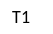

Brand loyalty

H4

Diagram 2 - Structural dimension model of internet retail brand equity

Chapter 5- Research Methodology

Introduction
In previous chapter, a conceptual model to assess customer-based brand equity for internet retailers has been identified and developed. This chapter aims to review and evaluate the alternative methodologies to identify an appropriate methodology and research design and justify it to be used for examination of the proposed conceptual model.

Evaluation of the alternative research paradigms

As previously mentioned, this dissertation aims to explore the question “How customer-based brand equity can be measured in the context of internet retailing?” To find answer, the required relevant secondary and primary data must be collected. In literature review chapters, required secondary data and previous conducted researches has been presented. In this chapter primary data through the application of the appropriate instruments and qualitative and quantitative approach, will be collected and implemented to test proposed conceptual model.
Exploratory research would be conducted to understand marketing phenomena that are inherently difficult to understand. Thus, the nature of this research in qualitative phase will be exploratory which provides understanding and insights with flexible and evolving approach and aims to identify the right variables to achieve the objectives of this research.
Moreover, the quantitative research in this dissertation would be more conclusive because of the objectives which are the examination of the hypothesis suggested in the proposed model of brand equity for internet retailers in previous chapter. The quantitative phase more emphasis on frequency of occurrence and quantitative hypotheses testing, therefore, the nature of the quantitative research in this dissertation would be descriptive/ causal.
Concisely, in this dissertation, a complementary research through a qualitative exploratory research followed by quantitative descriptive/causal research has been chosen to achieve objective of this research sufficiently.
According to Malhotra and Birks (2006), qualitative and quantitative approaches to marketing research are underpinned by two broad philosophical schools namely positivist and interpretivism. Two main academic research paradigms have been identified as inductive and deductive paradigms.
Inductive research paradigm aims to understand individuals. It is value-based and has flexible process with wide variety of techniques. This paradigm is subjective, therefore multiple interpretational and as a result interactive, informal because of uncertainty of language. In other word, inductive research paradigm is qualitative and interpretive because it emphasise the in-depth study of individuals and small groups analysis and is based on interpretation of meaning not statistical testing. This paradigm is exploring inter-relationships and based on observation and conversation. In this qualitative paradigm, results described in words not numbers.
In other way, deductive research paradigm is base on positivist view which using natural science principles in social science and scientific methods. This paradigm aims to understand the world and is Positivism/ Empiricism, which emphasise that the world conforms to causal laws that enable explanation and prediction. It relies upon objectivity, rigor, and measurement and consists of prescriptive quantitative processes, limited methodological choice, and large samples to test hypotheses. In this dissertation, to achieve the objectives more sufficiently, the combination of both approaches has been considered.
Exploratory research methods classified as Focus groups, Depth interviews that are direct techniques and Expert/experience surveys, Repertory grid analysis, and Projective tests which are indirect techniques.
Descriptive research methods could be surveys such as ad-hoc and panel, large samples, standardised questionnaires and rapid statistical analysis with the aid of computer.
Focus group is discussions of the homogenous participants led by a moderator and is difficult to arrange. It needs co-ordination and moderating technique to control and lead group discussion.
Depth interviews are unstructured personal interviews to uncover underlying motivations, beliefs, attitudes, and feelings and would focus on the individuals. Depth interviews provide understanding of sensitive and underlying information, which are not possible to be expressed in focus groups. Depth interviews are easy to arrange with no need to co-ordination.
According to Malhotra and Birks (2006), repertory grid analysis, observation (Ethnographic) and Projective tests (motivational) are indirect method. Repertory grid analysis (Kelly, 1955), aims to strive participants to make sense of their environment by developing a personal construct system based upon their experience of the world. Observation methods are systematic which require, specific locations, times, data recording form, and systematic analysis which are not suitable for objectives of this dissertation. Projective techniques which are in the form of questioning, encourages respondents to project their feelings indirectly and verbalise complex personal feelings which are costly and time-consuming and not appropriate for the purpose of this dissertation. Therefore, with evaluation of the different techniques and base on preferences of researcher, depth interviews with content analysis, would be more appropriate in this dissertation and will be justified to achieve the objectives. (Malhotra and Birks, 2006, p.207)
Regarding data collection for quantitative research methods, two major groups of techniques could be distindused; Surveys and Observation techniques. Surveys techniques are mostly descriptive and causal research which measuring by asking questions whereas observation techniques are only descriptive and measuring by recording observations. Surveys could be Ad hoc surveys that are single sample at a point in time. To repeat this type of surveys, new samples are required. Panel surveys use same sample (panel) over repeated surveys and provides comparable measurement over time. Therefore, base on nature of this research, Ad hoc surveys will be used in this dissertation. Web survey with quota sampling of responses which are internet users, will be implemented in this research although there is the problem of biased responses.
In this dissertation, the chosen methods have been based on type of required data, budget, time, deadlines, and required speed. Three most commonly used approaches to analysing qualitative research are grounded theory, content analysis, and semiotics. Grounded theory approach has been criticised for its failure to understand implicit theories which constraint the observation and narrow it to particular prospective. This approach is not suitable when data analysis software will be used for analysing qualitative research. Therefore, in this research, this approach is not appropriate. Semiotics approach which combines various techniques from the disciplines like culture, psychology and visual arts has been criticised for its reliability .This approach is not appropriate and fit for this dissertation. Consequently, to analyse qualitative research, content analysis that reduce qualitative data by simplify, summarising and structuring is more appropriate for objectives of this research although it has few limitations for instant data fragmentation. Concisely, research methodology of this dissertation has been presented in Diagram 3.
Research Methodology
To assess a consumer-based model of brand equity in the context of internet retailing
Research Aim

Primary Data Qualitative
Primary Data Quantitative

Exploratory Research
Conclusive Research
Data Collections

In-Depth Interviews
Web survey

Sampling
12 internet users who use the online purchasing
100 internet users who use online shopping

Research Strategy
Descriptive/Causal Research
Content Analysis

Data Analysis
Data Analysis
using SPSS

Diagram 3 - Research Methodology of this dissertation
Primary data collection process
Qualitative Instrument
To evaluate proposed model of brand equity for internet retailers, structured questionnaire of eight open-ended questions has been developed.
Depth Interviews would be conducted with the use of questionnaire as instrument to understand the underlying motivation and thoughts that drives consumer’s attitude regarding online purchasing. The questionnaire has been specifically designed to capture the multi-dimensionality sources of brand equity for online retailers in the consumers’ mind.
The instrument was developed and pre-tested using a 10% sample of the main study sample size as a pilot. Figure I shows the topic guide for depth Interviews.

Figure I. Topic guide for depth Interviews

Why do you shop online and would you ever do it again? Why?
When was your last shopping online? What did you buy? Where? Will you ever do shopping again from it? Why?
What factors are important regarding online retailer you intend to shop on? Why?
Have you ever purchased online from an unknown unbranded website? Why?
What factors prevent or concern you to purchase from an online retailer? Why not?
Do you browse online before buying products? Why?
Would you ever prefer to pay more (premium price) but shop online on the well-known retailer branded website when shopping online? Why?
What aspects encourage you to re-purchase next time from an online retailer? Why?

Rationales for asking each question have been presented in Table 8.
Table 8 - Rationales for asking each question in qualitative Instrument
actual question | Question objective | Question`s analyse
Q1 | To understand the reasons which persuade consumers to shop online and to find out how it will create brand equity | Brand awareness → Brand Equity  Value perception → Brand Equity
Q2 | To understand the aspect of perceived value on consumers mind for online shopping and whether it will create repurchase intention and brand loyalty, to find out how it will affect brand equity | Value perception → Brand Equity  Brand loyalty → Brand Equity
Q3 | to identify the factors which customer consider when shopping online and how it will build-up brand equity | Value perception→ Brand Equity  Trust → Brand Equity
Q4 | To evaluate the effect of awareness and trust to create brand equity | Trust → Brand Equity  Brand awareness → Brand Equity
Q5 | To examine the effect of trust on brand equity | Trust→ Brand Equity
Q6 | To examine whether awareness and value perception will impress brand equity | Brand awareness → Brand Equity  Value perception → Brand Equity
Q7 | To understand whether perceived quality will resulted to brand loyalty to create brand equity | Brand loyalty→ Brand Equity  Value perception→ Brand Equity
Q8 | To identify the factors which create repurchase intention and brand loyalty and as result brand equity | Brand loyalty → Brand Equity

Qualitative Phase Sampling Plan

In this research, the population would be the internet users who use online shopping. As previously in literature review has been explained, the mostly probable demographic profile of internet retail shoppers is young people with convenience and frequent accesses to internet. According to Mintel (2010), the most frequent shoppers tend to be affluent young, well-educated internet users. Less frequent shoppers tend to be older and less affluent. One reason could be that internet is still a very young medium and mostly has been adopted by the young people and it consuming time to be penetrated and accepted by elderly people. Hence, it will be assumed that young affluent consumers potentially have more frequency of online shopping attitude towards purchasing favourite categories compared to the older less affluent consumers. Supporting this assumption, Mintel (2007) clearly has showed that the oldest age group reported (50+) is more likely used to buy PC in high street stores rather than online purchases. The age brackets have been used to distinguish as much as possible between two life cycle stages.
As a result and refer to Malhotra and Birks (2006: p.412), in this phase of research, a non- probability judgmental sampling technique based on three pre-determined quotas for a total of 12 internet user who have used online purchasing has been used:
- Gender (50% Male; 50% Female)
- Age (2 thirds “18-45”; 1 third “45+”)
- Occupation, (1 third “Students”; 2 thirds “Workers”)
The rationales for choosing this sampling technique would be the nature of this phase of research, which is exploratory, and being convenience, low cost, less time consuming for this dissertation and controlling certain characteristic for samples that are required to achieve the objectives of this research. The selection of samples on this phase is subjective.
Three groups of interviewees have been identified:
- Students (4 in-depth interviews)
- Workers F/T 18-45 year old (4 in-depth interviews)
- workers F/T 45+ year old (4 in-depth interviews)
The sampling plan for qualitative phase of this research has been presented in Table 9.

Table 9 - Qualitative Stage Sampling Plan for this research
AGE | GENDER | STUDENTS | F/T WORKERS | TOTAL
18-45 | MALE | 2 | 2 | 8
18-45 | FEMALE | 2 | 2 | 8
45+ | MALE |  | 2 | 4
45+ | FEMALE |  | 2 | 4
 |  | 4 | 8 | 12

The technique of recruiting people which has been used for this phase of research is based on convenience sampling.

Quantitative Instrument
To examine the hypotheses suggested in the proposed model of brand equity for internet retailers in previous chapter, a structured questionnaire contains of 10 questions has been developed.
The questionnaire has been exclusively designed to examine and capture the multi-dimensionality sources of brand equity for online retailers in consumers’ mind, which have been previously hypothesised in this research as brand loyalty, awareness, associations of value perception and trust. The aspects in the questionnaire reflect the sources of brand equity in consumer’s view and have been assessed on a 5-point Likert scale where 1 stands for “strongly disagree” and 5 for “strongly agree”.
The measures, which are the reflection of brand equity in consumers mind, could be:
- Price premium: that is the consumer’s intention to pay a price premium for shopping on a particular internet retailer website (brand) in comparison to another less well-known website. Ailawadi and Keller (2004) pointed out that several researchers (Aaker, 1991, 1996; Park and Srinivasan, 1994; Chaudhuri and Holbrook, 2001; Ailawadi and Keller, 2004) have considered price premium as a measure of brand equity. The premium price mentioned in the questionnaire is derived from Smith et al.'s (2000) findings that consumers were willing to pay a premium of 6.8 per cent when buying from an online store where they had shopped before.
- Re-purchase intention from the website brand: which has been created by consumer`s awareness of the branded website, value perception and trust associations with the internet retailer brand and loyalty towards it.
The questionnaire, which will be used in quantitative phase, has been presented in Figure II.
Figure II. Structured Questionnaire

Q1. Please select your gender | Male | Female
Q2. What is your age range? | 18 - 25  26 - 35 |  | 36 - 45  45+  ⁪  ⁪  ⁪  ⁪  ⁪  ⁪  ⁪  ⁪  ⁪  ⁪  ⁪  ⁪  ⁪  ⁪  ⁪  ⁪  ⁪  ⁪  ⁪  ⁪  ⁪  ⁪  ⁪  ⁪  ⁪
Q3. What is your present occupational position or (if no longer working) was your last position?
- Higher managerial, administrative or professional
- Intermediate managerial, administrative or professional
- Supervisory or clerical, and junior managerial, administrative or professional
- Skilled manual workers
- Semi and unskilled manual workers
- Do not have any work experience

Below are a number of statements referring to online purchase attitudes and your experience of shopping on the web in general. Please read each one and indicate whether you agree or disagree with it, by ticking one box for each statement.
 | Strongly Disagree 1 | Disagree  2 | Neither agree or disagree 3 | Agree  4 | strongly Agree 5
Q4. I must definitely know the website I intend to purchase on it
Q5. I prefer websites which offer lowest prices for a better quality branded products
Q6. I prefer websites that offer variety range of products and alternative forms of payments
Q7. The website I shop on must be reliable and have orders tracking facility and refund policy
Q8. I must feel safe to disclose my personal information and have confident to security of a website to conduct transactions on it
Q9. I prefer to pay more (premium price) but purchase from reputed website
Q10. I would definitely consider shopping again from a website which I have a pleasant and valuable shopping experience on it in future

Rationales for asking each question have been presented in Table 10.
The instruments were developed and pre-tested using a 10% sample of the main study sample size as a pilot.

Table 10- Rationales for asking each question in quantitative Instrument
actual question | Question objective | Question`s analysis
Q1, Q2, Q3 | To identify age, gender and socio-economic class of respondents which will be used to analyse of next questions | Gender, age and socio-economic class of consumers as strata to analyse the sources of brand equity in consumers mind
Q4 | To test hypothesis H1 that states, “Brand equity is correlated to consumer’s awareness about the Internet retailer brand positively.” | H1  Brand awareness → Brand Equity
Q5,Q6 | To examine hypothesis H2 that states, “Brand equity is correlated to consumers’ value perception associated with an internet retailer brand positively.” | H2  Value perception → Brand Equity
Q7, Q8 | To test hypothesis H3 that states, “Brand equity is correlated to consumers’ trust associated with an internet retailer brand positively.” | H3  Trust → Brand Equity
Q9, Q10 | To examine hypothesis H4 which states “Brand equity is correlated to consumers’ loyalty to an internet retailer brand positively.” | H4  Brand loyalty → Brand Equity

Quantitative Phase Sampling Plan

As in this phase web survey will be used, a stratified probability sample technique (Malhotra and Birks, 2006), from 100 internet users who have used online shopping will be implemented. The strata would be gender, age, and socio-economic class to ensure that sub-groups will be presented in this sample. The socio-economic classification is based on the NRS classification system (2010), which is presented on the question 3 of the quantitative questionnaire of this research.
The rationales for the choosing of this sampling technique would be the descriptive/causal nature of this stage of research and using web survey, which samples would be selected randomly. Being convenience to implemented, cost effective, less time consuming for this dissertation and controlling certain sub-population of the sample, which are the requirements to achieve the objectives of this research would be other reasons. Because the selection of samples on web survey is objective, the technique of recruiting people is random probability and partly based on snowball sampling.

Contact strategy for gaining cooperation / contacting respondents
Qualitative Phase
As sampling plan for qualitative phase was judgmental, the potential samples has been identified and targeted by sending request letter via e-mail to invite respondents for interview. The request letter has been presented in APPENDIX I of this dissertation.
The anticipated response rate was around 30% and less than half of the targets declare their consent to participate in in-depth interview. In individual interviews, Topic guide, which is the key questions, have been implemented and discussed. When questioning, Interviewing techniques such as clarifying the key questions, expanding the discussion, and maximising respondent’s freedom of expression have been used. In-depth interviews transcripts have been presented in APPENDIX II of this dissertation.

Quantitative Phase
Because the sampling plan for quantitative phase of this research has been random probability, collected by web-survey, a quantitative structured questionnaire, by using appropriate web-survey software, has been designed, and a public request on the variety of websites, contains of the web-survey link, has been published. The web-survey link has been clearly placed in the request to easily navigate respondents to the web-survey. However, the response rate was very low. Therefore, complementary strategies for gaining cooperation of respondents had to be implemented such as use of social networks with snowball sampling techniques and in- street (mostly in libraries) direct interviewing to raise the rate of participate respondents. The request to invite people to participate in web-survey has been presented in APPENDIX I of this dissertation.

Data processing / analysis
Qualitative Phase
The primary data collected through in-depth interviews, will be processed and analysed by content analysis method and appropriate points will be illustrated by the use of extensive verbatim quotations. All in-depth interviews have been recorded and then summarised, transcribed and coded with the help of the appropriate software, Excel. In-depth interviews transcripts have been presented in APPENDIX II of this dissertation.
This phase of research aims to examine proposed model of brand equity for internet retailers. As previously explained, content analysis would be used in this research to capture the multi-dimensionality sources of brand equity for online retailers in consumers’ mind and understand the underlying motivation and consumer’s attitude.

Quantitative Phase
The primary data collected by surveys, will be processed and analysed by statistical methods such as frequencies or percentages, using an appropriate software, SPSS. This phase of research
aims to examine proposed hypotheses in the model of brand equity for internet retailers by implementing statistical techniques and tables which have been presented in APPENDIX III of this dissertation to clarify whether the proposed model is fit and appropriate.

Conclusion
In this chapter, different approaches and paradigms to find the appropriate methodology to collect and analyse primary data and conduct this dissertation, has been discussed and evaluated. As a result, it has been identified that complementary of qualitative and quantitative research method would be more appropriate to conduct this research.
In qualitative research with In-Depth Interviews, data processing and analysis due to small size of sample will be performed in terms of relevant interpretation of data and in the light of the research objectives and literature review chapters whereas in quantitative phase, data will be reported in terms of statistic analysis due to relatively large sample size. For each phase, the instrument, sampling plan, strategy for primary data collection, analyse, and process of data with objectives and rationales for choosing them, has been discussed. Consequently, in next chapter, the empirical findings and analysis will be presented to achieve the objective of this research.

Chapter 6- Empirical Findings & Analysis

Introduction
In this chapter, the raw/processed data collected in qualitative and quantitative phase, which has been presented in APPENDIX II & III of this dissertation, will be analysed. In qualitative phase with in-depth interviews, data processing and analysis due to sample size of sample will be performed in terms of relevant interpretation of data and content analyse, in the light of the research objectives and literature review chapters whereas, in quantitative phase, due to relatively large sample size, data will be reported and analyse in terms of statistic analysis.

ANALYSIS OF FINDINGS
Quantitative research findings and analysis

- Why do you shop online and would you ever do it again? Why?
I mainly shop on line because I can browse many websites within minutes. Finding specification of a product is more convenience on line. This enables me to make an informed choice with ease and maybe even cheaper price. Male, 51, Worker
I shop online because it is easier to find what I am looking for in shorter time. Sometimes I can find good deal and bargains too. Yes, I would shop again and I will never say “never” although had my bad experiences too. Male, 48, Worker

From the small sample involved in this stage, it appears that the main reasons which all respondents declared for purchasing online has been convenience and cheaper price. Half of the respondents indicated other reasons such as time saving and free/cheap delivery. Minority of them (cited 2 times) mentioned to obligation and availability. All participants confirmed that they would continue online shopping. It confirms literature review, which explained that the internet has facilitated purchasing experience and has established strong desire to be used on daily life and continue to expand in future. Online shopping has created value and comfort and provides more information for consumers. Internet has changed shopping altitude and has been popular and desirable to the extent which creates value, awareness and facilitate consumer’s life. It means that in the brand strategy, online retailers must highly effort to offer values such as reasonable prices and convenience shopping experience to impress consumer’s value perception and consequently create repurchase intention and brand loyalty, which would be brand equity in consumers mind.
I use online shopping because it is easier and cheaper. For example, I have purchased some books from Amazon, which it was more convenience for me to buy books online and it was cheaper. Definitely for sure, I will shop again if I need it. Female, 24, Student

- When was your last shopping online? What did you buy? Where? Will you ever do shopping again from it? Why?
I bought a laptop 3 weeks ago. I bought it from HP.com because if I bought it directly from the company I could get it personalised, and also it was much cheaper than in stores. Female, 26, Student
I think 6 months ago, as I said I rarely use online shopping I`ve done shopping of book from Amazon. Yes. If I find a good cheaper deal, compare to stores I will shop again. They are reliable, trust-worthy and provide free delivery service with cost saving. Female, 55, Worker
Two weeks ago, I bought a Webcam from EBay because it was much cheaper than stores. Yes, I will shop on EBay if I find a bargain or good deal because I had a good shopping experience on EBay. Male, 22, Student

Two third of the sample who were under 45 years old, declared that they have recently purchased online. However one third of older respondents who are above 45, stated that they have used online shopping long time ago (more than 4 moths) which will confirm literature review which indicated that the youngsters are more interested and tend to online shopping and have accepted and used it more than elders. From the small sample involved in this phase, it seems that most frequent users of online shopping are under 45 and more interested and desired to use online purchase. Nevertheless, the older respondents may show a sense of reluctant and cautious. The explanation might be as previously explained in literature review, internet is a young medium and consuming time to penetrate and be accepted by older generation, which are more conservative and avoid engaging in the risks. All respondents mentioned that their most recent online purchase was from a well-known retailer like Amazon or trust-worthy websites in some extend, and all indicated their willingness to shop again from this website in future. For reasoning, they all attribute positive values such as reliability, lower price and convince that provided them pleasant shopping experience on that website. It appears that previous online shopping experience has created value in consumer’s perception, which would be resulted on intention for re-purchase in future. Consequently, value perception in consumers mind is a important aspect to create consumer`s loyalty and would be a source of brand equity for consumer’s view for internet retailers.

- What factors are important regarding online retailer you intend to shop on? Why?
The quality should be good and the price should be reasonable. Online retailer must be famous and reliable. I know Lots of people tried these online purchasing and they were satisfied, so I think I will do it if I need that. Male, 24, Student
It must be reliable and offer various products and I like to find what I am looking for easily on website and have refund policy in the case if I recognise that it is not my desire product I want to return them. Female, 32, Worker
Somehow, you can find unique items or much more cheaper than the others real stores but in addition I expect on time delivery, easy shopping page and payment process. Male, 21, Student

The first and most important factor regarding online retailer, which all respondents stated in different expressions, was reliably and trust-worthy of online retailer. It presents that based on literature review and as hypnotised before, trust is necessary aspect in online shopping because of the lack of personal contact and interaction. Majority of participants states that offering good quality and reasonable prices with variety and wide range of product in retailer’s website, good customer service, and delivery and refund policy have been important factors regarding online retailers. Moreover, Minority of respondents mentioned other factors such as recommended by friends and family, friendly-use websites with easy navigation and offering promotional incentives as important factors. These responses would confirm that awareness and value perception are the most underlying desires and motivation of consumers relevant to online shopping attitude and trust is essential aspect which consumers consider when shopping online and emphasise that these aspects would be important sources of online brand equity in consumer`s mind.

- Have you ever purchased online from an unknown unbranded website? Why?
No, Never, because I cannot trust them and would not take the risk of giving my personal information and bank details to the people which I don`t know them. Female, 55, Worker
No. I can’t trust to share my details. Male, 48, Worker
Yes, I just found what I was looking for in this website and I had to risk and buy but I prefer to shop on websites, which I have heard much about them by my friends. Male, 22, Student

Two third of the of participants merely stated ‘No’ in regards to shopping from unknown unbranded website and the reason was lack of trust and concerns to disclose their personal and financial details to that websites. Other one third of the participants who replied ‘Yes’ stated that they could trust to that unknown unbranded website because of its approval by a reliable and secure website such as PayPal for transactions or recommendation of the family and friends (Cited 3 times) and only one respondent replied ‘Yes’ and indicated that his online shopping was risky but he carried out because he could find what he wanted only on that website. From the small sample involved in this stage, it appears that the main reason, which prevents respondents from shopping on unbranded online retailer, is lack of trust and reliability. Hence, it would confirm that in the internet environment, trust would ultimately affect shopping behaviour and would be important source of brand equity for online branding. Moreover, it appears that consumer’s awareness about an online retailer would be source of brand equity in form of brand recall. Based on literature review and (p.34) of this dissertation as Keller (2003) suggested, the customer high level of awareness and familiarity with the brand with some strong, favourable and unique brand associations in memory would be source of brand equity which enables consumers to retrieve the brand from the memory.
- What factors prevent or concern you to purchase from an online retailer? Why not?
Although it hasn’t stopped me, But make me doubt If I should shop online or not?? Two reasons which is mostly concerns me are firstly on line fraud and secondly, the description doesn’t match or show the true quality of the purchased item. Male, 48, Worker
My main concern about online shopping is the security of fund transfer and reliability to deliver the same products that I ordered on time. .Male, 25, Student
A few factors which concerns me are quality of product I want to purchase because on website it can`t be seen and tested and security. Sometimes the delivery and packaging also matters. Male, 29, Worker
Almost all respondents have expressed their concern about online fraud and security risks involves shopping online especially misuse of their personal information on bank accounts and credit cards. Half of participants also mentioned other factors that negatively affect their shopping behaviour such as impossibility to observe, touch, hold, or try the purchased product (cited 6 times), customer service issues such as delivery and refund policy. It presents their emphasise on the reliability and trust-worthiness of the online retailers. Thus, the importance of building-up the trust for online retailers with consumers is obvious and inevitable. Consequently, trust would be vital and valuable asset for online retailers and essential source of brand equity in consumers mind.

- Do you browse online before buying products? Why?
I always search about the product I`m looking for on internet by Google and try to compare price or quality and companies or websites which offering them to find the best deal. Female, 32, Worker

All the participants responded that they browse online before buying products using the well-known and popular search-engines such as Google. When probed, they mention good reasons to browse online. All respondents have indicated that they browse to compare the online retailers (websites) which offer that product. More than half the participants (cited 7 times) stated that the reason is price comparison and half the respondents stated that they browse online to compare variety of products. From the small sample involved in this phase, the responses were presented that the most important factors in online shopping which motivated consumers to brows before purchase in ranking order are: firstly, to find out the online retailers, which offer the product, secondly, price comparison and thirdly, compare the quality/variety of product online.
I definitely would browse to find the best product with the best price from a known retailer. Male, 48, Worker
Yes of course, I always Googling it to see different range of prices and the websites which sell the product I`m looking for. Male, 22, Student
It presents and highlights the importance of brand awareness and value perception in consumer’s point of view. Today, consumers are more sophisticated, complicated and level of awareness of consumers about different aspect involved in purchasing the right preferable products has been raised and consequently consumers are more quality/price-conscious and fickle. These points must be highly considered in brand strategy for online retailers. Accordingly, consumers’ awareness and value perception are important and affective source of brand equity in consumer’s view, which would result in consumer’s brand royalty.

- Would you ever prefer to pay more (premium price) but shop online on the well-known retailer branded website when shopping online? Why?

Majority of respondents expressed their willingness to pay price premium to purchase on the well-known branded websites. Only two participants merely stated ‘No’ and reasoned because of their preference to go with the cheaper price and their willingness to experience and explore variety of website. The reasons that the participants mostly preferred to pay more but shop online from branded retailers mostly were the risk of security and money losing which are involved to shopping from unbranded website although offers cheaper price (cited 8 times) and other reason was their preference to spend more money but receive better quality/ service (cited 3 times).

These responses again emphasise and highlight the importance of trust as a source of brand equity for online retailers in consumer’s mind, although unbranded websites offer cheaper prices but lack of trust prevents respondents from shopping on them. It means that the perceived value about an online branded retailer and trust, which has been created in consumers mind, enforce them to pay price premium. According literature review, It presents importance of power of brands which lies in consumers mind and consumers awareness with associations of trust and value perception would be essential source of brand equity for online retailers.
I would prefer branded retailers even their price would be bit higher than the un-branded because of the quality concern and the security. Male, 29, Worker
I would go with online branded retailers that I already knew them and I`m sure they are reliable because although maybe an unbranded retailer offer cheaper price but I cannot trust it and take risk. Female, 32, Worker
I prefer to pay more for well- Known brand retailer because I will pay more but the risk of losing money is less. Male, 22, Student

- What aspects encourage you to re-purchase next time from an online retailer? Why?
The factors such as good quality, quick delivery and fair price, easy return if there is fault, possibility of variety to choose, clear photograph of goods & details explanation of goods would encourage me to shop again from an online retailer. Female, 62, Worker
Reasonable Prices, punctuality to deliver the products, good and respectful customer service will encourage me to shop again on that website. Male, 25, Student
Time and cost efficiency in addition with the wider choice encourage me to shop again next time on the online store. Male, 29, Worker
Almost majority of the respondents (cited 10 times) declared that reasonable and fair price for good quality in their previous shopping experience from that website, would persuade them to return to the online retailer in future. Two third of respondents stated that quick delivery and good customer-care & service in previous shopping from that online retailer and refund and easy return policy would encourage them to
re-purchase. Almost half of the respondents mentioned to variety and wide range of products selection and time saving with easily navigation of website. From the small sample involved in this phase, it seems that all respondents explained different aspects of their perceived value in previous shopping from that website which will be resulted to their intention to repurchase in future and consequently brand loyalty. Hence, transferring sustain values from an online purchase by online retailer to the consumers mind which would be associated with value perception and trust, would enable online retailers to retain their consumers and build- up brand loyalty. This will persuade consumers to remember them for their next purchases in future. Consequently, it appears that creating value in consumer’s perception and establishing trust, will retain consumers and encourage them to continue shopping from that online retailer in future. This emphasise and confirm that sources of brand equity for online retailers in consumers’ mind would be associations of value perception and trust and as a result brand loyalty.

Summary of findings in qualitative phase
From the small sample involved in this phase, it appears that the proposed model of brand equity for online retailers in previous chapter consists of four dimensions: brand awareness, value perception, trust and brand loyalty, has been highly supported and approved by analysing the contents of in-depth interview responses. The interpretation of findings and analysis of this qualitative phase support the proposed hypothesises which states that a consumer’s awareness and perceived sense of value because of transaction with an online retailer and experiencing quality service, develops brand-trust association intention for re-purchase in future, which led to creation of brand loyalty. In other word, it appears that consumer’s awareness about an online retailer would be source of brand equity in form of brand recall. Based on literature review and (p.34) of this dissertation as Keller (2003) suggested, the customer high level of awareness and familiarity with the brand with some strong, favourable and unique brand associations in memory would be source of brand equity which enables consumers to retrieve the brand from the memory. Therefore, brand awareness, in the form of brand recall ,directly contribute to creating brand equity. Loyalty is the most important source of brand equity because of its mediating role to create value by consumers re-purchases and consequently, strong direct influence to create brand equity.
Quantitative research findings and analysis
Q1. Please select your gender
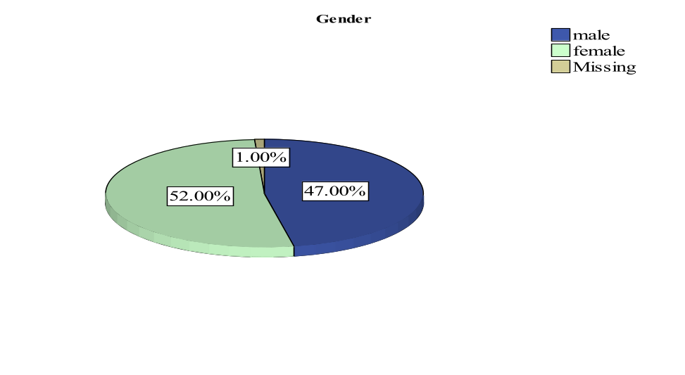
From the sample of 100 respondents to survey, 47 male and 52 female have participated in this phase of research. Gender of consumers has been used as strata to analyse the next questions, which resulted to examination of proposed sources of brand equity in consumers mind.
Q2. What is your age range?
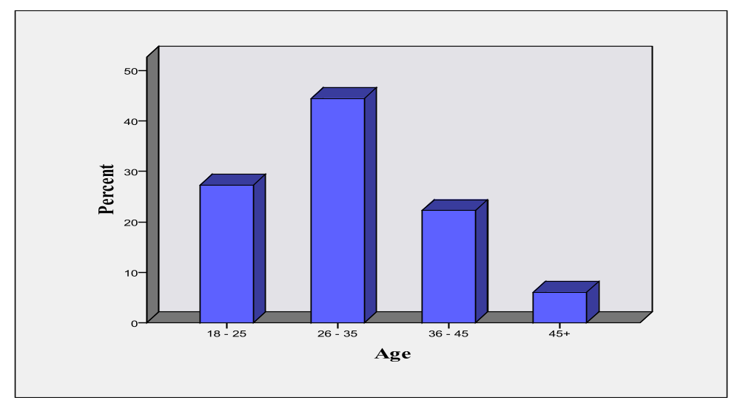
From the sample of 100 respondents to survey, considering the age range as strata, %27 age of 18-25, %44 age of 26-35, %22 age of 36-45 and %6 age of 45+, have participated in this phase of research. This data could be used to analyse next questions.

Q3. What is your present occupational position or (if no longer working) was your last position?
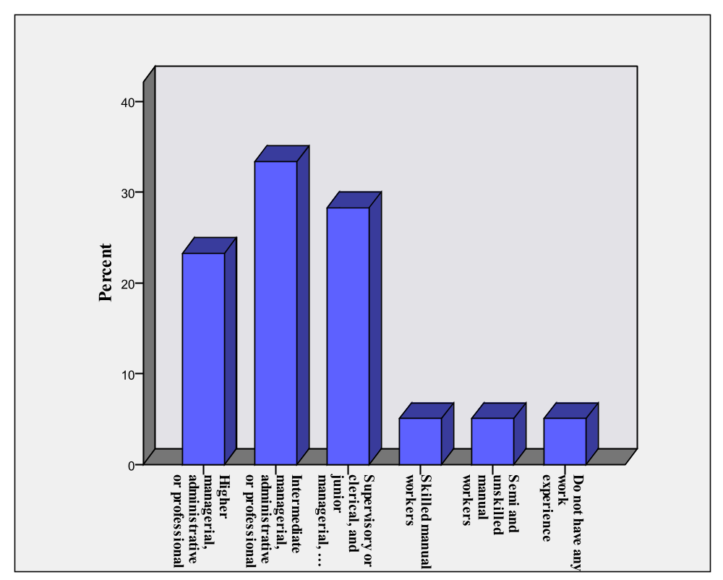
This Socio-economic classification presented on this question is based on the NRS classification system (2010). From the sample of 100 respondents to survey, considering Socio-economic class as strata, Higher managerial, administrative or professional (A Socio- economic class) %23, Intermediate managerial, administrative or professional (B Socio- economic class) %33, Supervisory or clerical, and junior managerial, administrative or professional (C1 Socio-economic class) %28, Skilled manual workers (C2 Socio- economic class) %5, Semi and unskilled manual workers (D Socio- economic class) %5, Do not have any work experience
(E Socio- economic class) %5, have participated in this phase of research. This data could be used to analyse next questions.

Questions Q4 to Q10 have been designed base on objectives of this research, to examine source of brand equity for online retailers in consumers mind and to test the proposed hypothesises in conceptual development chapter to identify if the proposed model of band equity for internet retailers is fit and appropriate. a few statements regarding online purchase attitudes and consumers shopping experiences on the web in general have been presented and asked participants to indicate whether they are agree or disagree with each statement. Likert scale with five categories with rating scale from 1= Strongly Disagree to 5= Strongly Agree has been used to evaluate attitudes towards online shopping by indicating the degree of agreement or disagreement with each of series of statements.
To analyses, each statement is assigned a numerical score, rating from 1 to 5. For each statement by using consistent scoring procedure, a high score consistently reflects a favourable response, which has been supported by majority of respondents and consequently would be the approval of the proposed hypothesis correlated to that statement. Higher scores would be devoted to attitudes that are more favourable. In contrast, low scores present disagreement and indicate that majority of respondents has not supported the correlated hypothesis to that statement and as a result, the proposed hypothesis would not be approved. In this phase, Mean is an appropriate indicator to present attitude score and the average value of agreement with the statement by majority of respondents. The processed data collected in quantitative phase, from the sample of 100 respondents by implementing SPSS software, statistically analyse of quantitative primary data, has been presented in APPENDIX III of this dissertation and table 11. The analysis of each question would be presented as followings.

Table 11 - Descriptive Statistics
 | N | Mean |  | Std. Deviation | Variance
 | Statistic | Statistic | Std. Error | Statistic | Statistic
Q4. I must definitely know the website I intend to purchase on it | 100 | 3.60 | .102 | 1.025 | 1.051
Q5. I prefer websites which offer lowest prices for a better quality branded products | 100 | 4.10 | .080 | .798 | .636
Q6. I prefer websites that offer variety range of products and alternative forms of payments | 100 | 4.12 | .073 | .729 | .531
Q7. The website I shop on must be reliable and have orders tracking facility and refund policy | 100 | 4.39 | .067 | .665 | .442
Q8. I must feel safe to disclose my personal information and have confident to security of a website to conduct transactions on it | 100 | 4.73 | .049 | .489 | .239
Q9. I prefer to pay more (premium price) but purchase from reputed website | 100 | 3.58 | .105 | 1.046 | 1.095
Q10. I would definitely consider shopping again from a website which I have a pleasant and valuable shopping experience on it in future | 100 | 4.72 | .049 | .494 | .244
Valid N (listwise) | 100

Q4. I must definitely know the website I intend to purchase on it
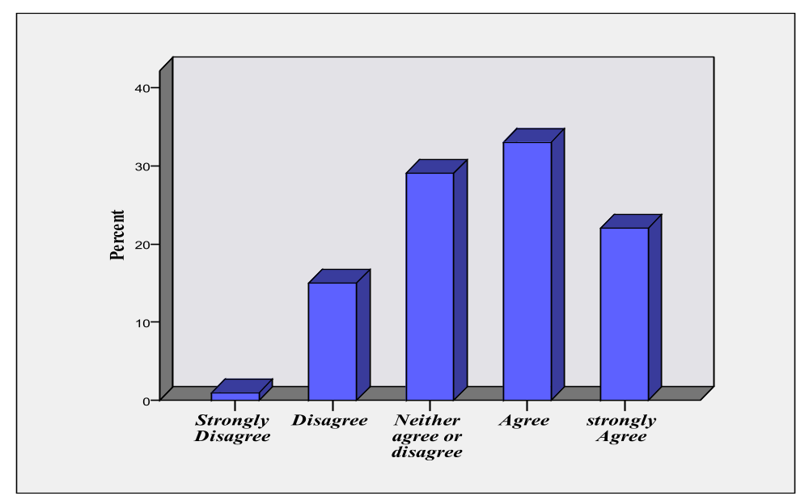

From the sample of 100 respondents, %1 rated Strongly Disagree, %15 rated Disagree, %29 declared Neither agree or disagree, %33 indicated Agree and %22 rated strongly Agree. According to Table 11, Mean for this value is 3.60 with the relatively high Standard Deviation and Variance of approximately 1, which indicated that the sample result is far from what has already been hypothesised (H1) and this statement and its accuracy, has not been highly supported by majority of respondents. It might interpreted that relevant proposed hypothesis (H1) would not been well correlated with online brand equity. In other word, the Mean shows that H1 has not been rejected by majority of respondents either. This could be explained base on literature review and (p.34) of this dissertation as Keller (2003) suggest that CBBE occurs when the customer has a high level of awareness and familiarity with the brand and holds some strong, favourable and unique brand associations in memory. Hence, brand awareness could be source of brand equity when it is in the form of brand recall, which enables consumers to retrieve the brand from the memory. Thus, brand awareness would be source of brand equity when it is in the form of brand recall and when awareness in some situation is in the form of brand recognition, it might have an indirect influence on consumer based brand equity for internet retailer.

Q5. I prefer websites which offer lowest prices for a better quality branded products
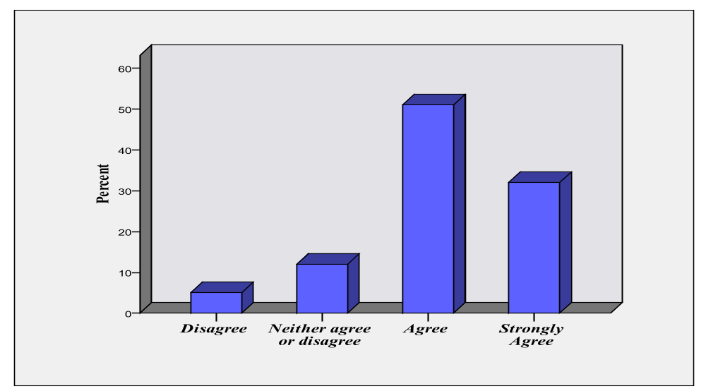

From the sample of 100 respondents, %5 rated Disagree, %12 declared Neither agree or disagree, %51 indicated Agree and %32 rated strongly Agree. No respondent rated Strongly Disagree. According to Table 11, Mean for this value is 4.10 with the relatively small Standard Deviation o.79 and Variance of approximately 0.63, which indicated that the sample result is nearby of what has already been hypothesised (H2) and this statement and its accuracy, has been supported by majority of respondents. It could interpreted that relevant proposed hypothesis (H2) would been well correlated with online brand equity. In other word, the Mean shows that H2 have been supported by majority of respondents. Therefore, it would be assumed that association of value perception might have an direct influence on brand equity for internet retailers and it has been highly important as considered and hypothesised as a source of brand equity for online retailers.
Q6. I prefer websites that offer variety range of products and alternative forms of payments

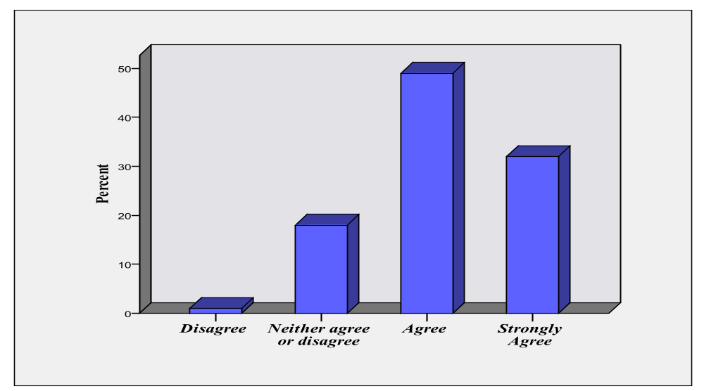

From the sample of 100 respondents, %1 rated Disagree, %18 declared Neither agree or disagree, %49 indicated Agree and %32 rated strongly Agree. No respondent rated Strongly Disagree. According to Table 11, Mean for this value is 4.12 with the relatively small Standard Deviation o.72 and Variance of approximately 0.53, which indicated that the sample result is nearby of what has already been hypothesised (H2) and this statement and its accuracy, has been supported by majority of respondents. It could interpreted that relevant proposed hypothesis (H2) would been well correlated with online brand equity. In other word, the Mean shows that H2 have been supported by majority of respondents. Therefore, it would be assumed that association of value perception might have an direct influence on brand equity for internet retailers and it has been highly important as considered and hypothesised as a source of brand equity for online retailers.

Q7. The website I shop on must be reliable and have orders tracking facility and refund policy

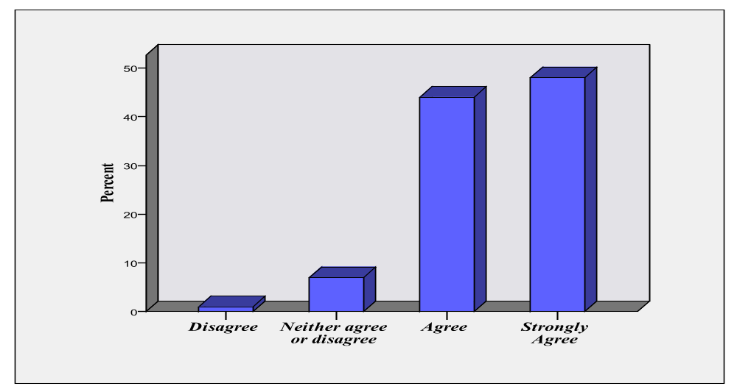

From the sample of 100 respondents, %1 rated Disagree, %7 declared Neither agree or disagree, %44 indicated Agree and %48 rated strongly Agree. No respondent rated Strongly Disagree. According to Table 11, Mean for this value is 4.39 with the relatively small Standard Deviation o.66 and Variance of approximately 0.44, which indicated that the sample result is nearby of what has already been hypothesised (H3) and this statement and its accuracy, has been supported by majority of respondents. It could interpreted that relevant proposed hypothesis (H3) would been well correlated with online brand equity. In other word, the Mean shows that H3 has highly been supported by majority of respondents. Therefore, it would be assumed that association of trust combined with value perception might have an direct influence on brand equity for internet retailers and it has been highly important as considered and hypothesised as a source of brand equity for online retailers.

Q8. I must feel safe to disclose my personal information and have confident to security of a website to conduct transactions on it

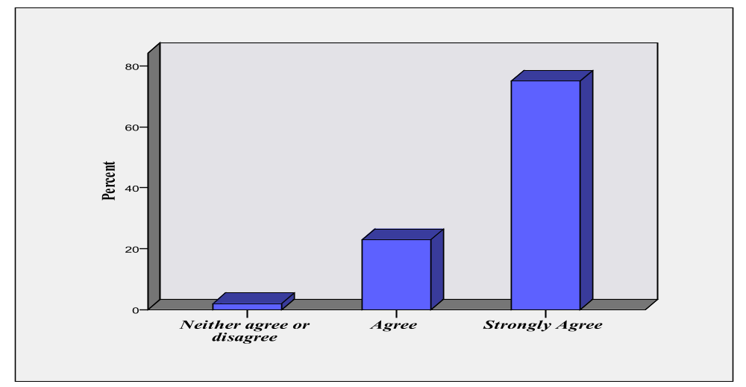

From the sample of 100 respondents, %2 declared Neither agree or disagree, %23 indicated Agree and %75 rated strongly Agree. None of respondents declared Disagree or Strongly Disagree. According to Table 11, Mean for this value is very high 4.73, with the relatively very small Standard Deviation o.48 and Variance of approximately 0.23, which indicated that the sample result is very nearby of what has already been hypothesised (H3) and this statement and its accuracy, has been highly supported by majority of respondents. It could interpreted that relevant proposed hypothesis (H3) would been well correlated with online brand equity. . In other word, the Mean shows that H3 have highly been supported by majority of respondents. Therefore, it would be assumed that association of trust will have an direct influence on brand equity for internet retailers and it has been highly important as considered and hypothesised as a source of brand equity for online retailers.

Q9. I prefer to pay more (premium price) but purchase from reputed website

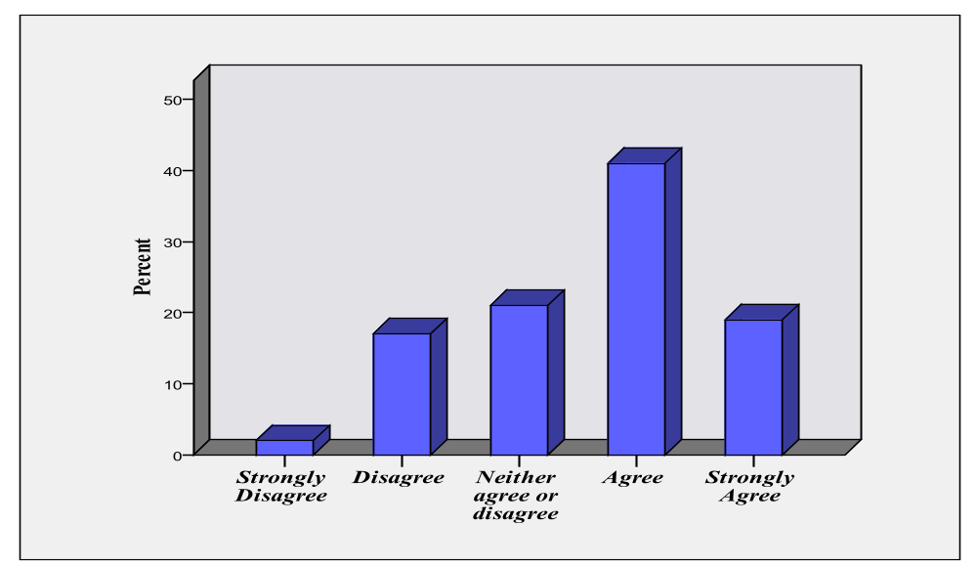
From the sample of 100 respondents, %2 rated Strongly Disagree, %17 rated Disagree, %21 declared Neither agree or disagree, %41 indicated Agree and %19 rated strongly Agree. According to Table 11, Mean for this value is 3.58 with the relatively high Standard Deviation and Variance of approximately 1, which indicated that this statement and its accuracy, has not been highly supported by majority of respondents or the sample result maybe far from what has already been hypothesised (H4) . It might interpreted that relevant proposed hypothesis (H4) would not been well correlated with online brand equity. In other word, the Mean shows that H4 has not been rejected by majority of respondents either. Therefore, it would be more appropriate to assume that price premium -the consumer’s intention to pay a price premium for shopping on a particular internet retailer website (brand) in comparison to another less well-known website- would not be a suitable measurement and reflection of brand equity in consumers mind. Therefore, literature review has not been supported by this research. It is possible that price premium could be consider as indirect influence on brand equity for internet retailers or may affect brand loyalty indirectly. For proper reasoning, more researches must be done to clarify the correlation of price premium with brand loyalty.
Q10. I would definitely consider shopping again from a website which I have a pleasant and valuable shopping experience on it in future

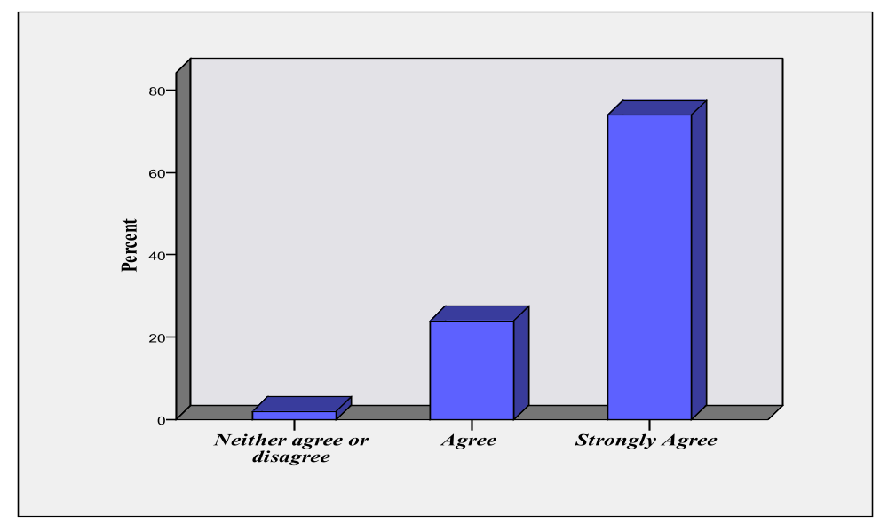

From the sample of 100 respondents, %2 declared Neither agree or disagree, %24 indicated Agree and %74 rated strongly Agree. None of respondents declared Disagree or Strongly Disagree. According to Table 11, Mean for this value is very high 4.72, with the relatively very small Standard Deviation o.49 and Variance of approximately 0.24, which indicated that the sample result is very nearby of what has already been hypothesised (H4) and this statement and its accuracy, has been highly supported by majority of respondents. It could interpreted that relevant proposed hypothesis (H4) would been well correlated with online brand equity. In other word, the Mean shows that H4 has highly been supported by majority of respondents. Therefore, it would be assumed that brand loyalty will have an direct influence on brand equity for internet retailers and it has been highly important as considered and hypothesised as a source of brand equity for online retailers.

Summary of findings in quantitative phase
From the relatively large sample involved in this phase, it appears that the proposed model of brand equity for online retailers in previous chapter, consists of four dimensions: brand awareness, value perception, trust and brand loyalty, and hypothesises relevant to this model (H1,H2,H3,H4) have been supported and approved . According to questions Q4 to Q10 and table 11, which presents analysis of quantitative primary data, The statistical examination of findings and analysis of quantitative data highly support the proposed hypothesises (H3, H4) and H2 in a way that consumer value perception as a result of transaction with an online retailer and experiencing quality service, develops Brand-trust association and then intention for re-purchase in future which would result to brand loyalty. Findings present partially support of H1, which could be interpreted base on literature review and (p.34) of this dissertation as Keller (2003) suggest that CBBE occurs when the customer has a high level of awareness and familiarity with the brand and holds some strong, favourable and unique brand associations in memory. Hence, brand awareness could be source of brand equity when it is in the form of brand recall with strong attached associations, which enables consumers to retrieve the brand from the memory. would be direct source of brand equity and when awareness in some situation is in the form of brand recognition, it might have an indirect influence on consumers and indirectly contributes to creating brand equity through its influence on value perception and trust association, which led to creation of brand loyalty. Brand loyalty is the most important source of brand equity because of its mediating role to create value by consumers re-purchases and consequently, directs influence to create brand equity. Therefore, the proposed model of brand equity for online retailers in consumer’s point of view with dimensions namely: Associations of value perception, trust and brand loyalty have been approved and passed the test by statistic analysing of responses. Brand awareness has not gain appropriate rate of approval to pass the test but H1 has not been rejected either. Thus, it would more appropriate to hypothesis that Associations of value perception, trust and brand loyalty are the direct source of brand equity and brand awareness is direct source of brand equity for internet retailers when it is in the form of Brand Recall. Further analyses could be resulted from this research for instance correlation of gender, age and social-economic class to the source of consumer based brand equity for online retailers and the findings could be analyse from different angles with cross-tabulation which would be out of the frame of this dissertation and therefore will not proceed.
Chapter 7 - Conclusions / Recommendations

Summary of the research and the key findings

Brands are the most valuable assets of the companies and brand equity can affect and raise the financial value of a brand. Hence, Brand equity has been an important and interest topic of research in the marketing area. Internet retailing has been recently popular for its convenience, technological upgrades, and security improvements, which have made shopping via the Internet more pleasant, safe, and affordable, and eventually internet retailers undercut store-based players on price. Internet retailing industry is a fast-growing, dynamic, and innovative area which expanding rapidly and has been attractive and interesting in recent years. For measuring brand equity, different school of thoughts such as consumer-based brand equity and financial brand equity has been proposed. In this dissertation, the customer-based approach, which is the assessment of the brand equity from the customer’s point of view, has been implemented. While many studies have been conducted to identify and ratify the source of brand equity for traditional store-based retailers, few have been conducted with online retailers. Therefore, this research contributes to Internet retail marketing field by bridge the gap of insufficient researches in this marketing area.
This dissertation has been the presentation of the complementary qualitative and quantitative research through exploratory and conclusive approach to assess brand equity from consumer’s point of view in the context of internet retailing. First, Literature review in the prospect of sector overview and marketing theory conducted to research secondary data and review academic literature relevant to the internet retailing industry and brand equity. Previous researches reviewed and evaluated to understand what has been achieved before and followed by identification of relevant propositions about brand equity based on a traditional conceptual framework, Aaker (1991, 1996). Consequently, a conceptual model of brand equity for internet retailer’s base on literature review had been developed which used as a principal for data collection. Four sources were hypothesised to create brand equity awareness, associations of value, trust and loyalty. It was hypothesised that brand equity, expressed both as the willingness to pay a price premium for shopping on a specific online retailer web site versus another less well-known web site, and by the intention to re-purchase from that web site, would be influenced by consumer awareness of the branded website, perceived value and trust associations with the online retailer and loyalty towards it. Then Research Methodology for primary data collection to examine and evaluate this proposed model of brand equity for internet retailers by using qualitative and quantitative methods and analyses of primary data using content analysis (for qualitative data) and SPSS (for quantitative data) had been conducted. as a result, it seemed that the proposed model of brand equity for internet retailers has been approved and supported by our qualitative and quantitative phase, but in a way that base on literature review and (p.34) of this dissertation as Keller (2003) suggest, brand awareness could be source of brand equity when it is in the form of brand recall, which enables consumers to retrieve the brand from the memory which has hold some strong, favourable and unique brand associations. Thus, brand awareness in the form of brand recall would be direct source of brand equity and when awareness in some situation is in the form of brand recognition, it might be indirect source of CBBE by influencing value perception and trust association, which led to creation of brand loyalty. Brand loyalty is the most important source of brand equity because of its mediating role to create value by consumers re-purchases and consequently, directly influences to create brand equity.
Hence, the proposed model of consumer based brand equity for internet retailers would be combination of Aaker (1991) and Keller (2003), consist of dimensions namely: Brand Awareness (Brand Recall), Associations of value perception, trust and brand loyalty, which had been examined by qualitative and quantitative phase of this research and presented that it is fit and appropriate for assessment of consumer- based brand equity for internet retailers. In the current research, this conceptual framework has been supported and approved by qualitative and quantitative research. This study suggest that Brand awareness influences the association of value and trust that customers make about a brand and afterward these associations influence loyalty, which led directly to creating brand equity.

Recommendations and managements implications

This research would provide valuable insights and concepts regarding consumer-based brand equity for internet retailing. Hence, this study assists marketers to obtain necessary prospects and insights to find the ways to make online brands more affective and profitable. As mentioned in this research, brand equity strengthens online retailers by increasing their effectiveness in marketing communication and lower costs of distribution and growth opportunities. This research provide academic marketers, marketing managers and practitioners valuable concepts and prospective about source of brand equity for internet retailers and emphasise the importance of brand value and image in consumers mind for online retailers, which can be used for the planning of brand marketing strategy to strengthen the internet retailing brands.
Proposed model to assess consumer-based brand equity for internet retailers could be used to manage online retailers brand sufficiently or to build-up a new online brand retailer from stretch.
The research has valuable management implications for practitioners. The proposed model of consumer-based brand equity for online retailers have presented that Brand Awareness in the form of (Brand Recall), Associations of value perception, trust and brand loyalty, would be the source of online brand equity in consumers mind. Therefore, managers would be recommended to seriously pay attention to these aspects when planning marketing strategy and make effort to implement the strategies in line with dimension of proposed model to achieve strong online brand equity in consumers’ mind. These aspects must be considered for marketing mix and marketing communication relatively.
According to this model, it appears that association of value perception is an important aspect in creating Internet brand equity. Thus, managers are recommended to identify what constitutes value for their consumers as compare with their competitors. In this research, consumers perceived value of online retailers were in the availability of a broad range of products, secure online transaction, lower price and value for money and a tool that enables them to compare prices.
This research indicates that brand awareness, in the form of brand recall, which enables consumers to retrieve the brand bonded with strong and favourable brand associations from the memory, would be source of brand equity. Awareness of online retailer could be established on variety methods such as effective marketing communication. It would recommended to managers that with implementing appropriate strategy for marketing communication and marketing mix, make effort to create high level of awareness in consumers mind, familiarity with the online brand and build-up some strong, favourable and unique brand associations in consumers memory .
When awareness in consumers mind is in the form of brand recognition without any attached association, it might have an indirect influence on consumer based brand equity for internet retailer. It is recommended to managers that once consumer’s awareness and brand recognition have reached a threshold, the online retailer brand vigorous attempt should move to communicate value and reinforce loyalty.
This research supports the view that trust may be even more important in a computer-mediated environment than store-based retailers and demonstrates that trust is central to exchange values and has a direct and strong influence on loyalty, which is a cornerstone of brand equity, and is important aspect to create online brand equity in consumers view. Thus, building- up consumers trust by developing brand-marketing activities to create trust is necessary. Hence, managers are recommended to identify what values constitutes trust for their consumers as compare with their competitors. In online branding, consumers trust can be build-up by demonstrating secure and professional-looked website, which provide safe and secure environment for online transaction. Base on this research, it had been understand that trust extremely affect consumers shopping behaviour which managers must seriously consider trust building with consumers as principle and priority for online brand strategy and planning. For instance, according to in-depth interviews responses, with linking to highly trust-worthy brands like PayPal which not sharing the bank account detail with online retailer or offering it as the one of the payment methods, could assure consumers about transaction and security of payment which is the most concern of online shoppers.
As presented on qualitative in-depth interviews, consumers are mostly assure and certain about shopping from the website of store-based retailers brands such john-Lewis because they generalise their same trust to online shopping from its website, and expect the same value which they have already perceived in purchasing from store-based, from online retailer. However, regarding to brand awareness, the online retailer had been recommended by family or friends to purchase from a website or had seen or heard its advertisements in trust-worthy public media. It presents the importance of marketing brand communication and marketing mix strategies to create and build-up awareness, trust, and value perception for online retailer brands.
As mentioned in literature review, Amazon have a top awareness because of high service quality, offering lower prices and free delivery which presents the importance of quality service perception to consumers to build up awareness and trust, and when consumers experienced pleasant shopping and perceived high quality of service from a online retailer, they would be encourage to re-purchase on it in future which would be resulted in brand loyalty that is the most important asses of brands. They would recommend that online brand to their family and friends, which improve brand awareness and image in market and would make profit and high volume of sale for it.

Limitations of the research

This research posed some challenges, which are common to social science researches and is subject to some limitations. It is possible that the study suffers from some common methods bias.
To extrapolating, the findings of this research must implement cautiously specially to predominantly virtual brands.
The study may have limited generalisations in the sampling for in-depth interviews. Because the judgmental convenience sampling has been used, the finding in qualitative phase may have bias towards sample selection, samples may not be representative, and result could not generalise. This research has relative limitation regarding use of web-surveys such as possible bias in targeting samples because mostly young online shoppers under 45 are heavily internet user therefore, samples above 45+ could not been targeted sufficiently. In web surveys, that had potential for very large samples, response was very low rate and because of lack of manipulation, biased for instance Female samples were larger than males as because of nature of this research, sample frame could not been defined. This sample will certainly not reflect a sample of the whole population in quantitative phase because sample framework, has not been recognized, Web penetration is still low which occur bias of access to the samples and consequently limitation for this research.
Online shopping behaviour could be affected by socio- economic and cultural factors and language skill of people from outside of U.K, which could influence the collected data. However, this sample may be appropriate for theory testing and development because the population targeted in this research do purchase products from the online retailers.
This study has not included interaction impressions. Potential interactions among the sources of brand equity such as trust and loyalty on brand equity outcomes could provide additional insights.
It must be considered that although the theoretical framework in this research seems to be sturdy but brand equity sources could have a different impact on brand equity when studying online businesses in portals and verticals point of views.
Because the quantitative phase of this study is cross-sectional and there was no variable manipulation, the findings must be interpreted with caution. The observable variables, which used in this research, may not be to the required extent comprehensive.
Comparing the proposed model against that of rival ones, its results must be interpreted with caution.

Reflection on the research process

As resources of this research such as budget and time- scale was restricted, it has been attempted to collect primary data through different strategies, which was difficult and frustrating. For web- survey, the responses were very low; therefore, social networks and snowball methods had been implemented to raise the response rate. In other effort to collect primary data, in street and library interviewing had been applied which was exhausting and time-consuming.
For in-depth interviews, encouraging people to participate in interview was difficult and despite sending many invitations and requesting people, few accepted to participate in in-depth interview. For in-depth interviews because rapport of participants was required, in street interviews was less effective and hence, it was more appropriate to e-mail invitation and request them for interview.
If this research conducted again, sufficient budget and monetary fund to offer incentives to participants must be allocated to persuade people to participate in interviews. Despite all the constraints, a massive effort has been made to conduct this research sufficiently and achieve goals of this research appropriately.

Future research

As mentioned in this research in literature review, the conducted researches and attempts to assess brand equity for online retailers have been insufficient and scarce and the proposed models rarely has been examined. Consequently, further research is required to understand the applicability of the proposed online consumer-based brand equity model and by extension, the dynamic among the dimensions of brand equity.
As in this research, the variables may not be enough comprehensive, and interaction effects have not been taken in account, future researches needed to provide additional insights about potential interactions between the sources of brand equity such as trust and loyalty on internet brand equity.
Further analyses could be resulted from quantitative phase of this research, for instance correlation of gender, age and social-economic class to the source of consumer- based brand equity for online retailers, which would provide more insights. The findings could be proceed and analyse from different angles and prospective with cross-tabulation in future researches.

Bibolograghy

- Aaker, D.A. (1991), “Managing Brand Equity: Capitalizing on the Value of a Brand Name”, Free Press, New York, NY.

- Aaker, D. (1996), “Building Strong Brands”, Free Press, New York, NY.

- Aaker, D. (1996), “Building Strong Brands”, Brand week, February, Vol. 36 Issue 37, p28, 5p, [online] Academic Search Premier Database, EBSCO HOST.
Available at: http://0-web.ebscohost.com.emu.londonmet.ac.uk (Accessed 22.06.2010)
- Aaker, D. and Joachimsthaler, E. (2000), “Brand Leadership”, Free Press, London [online] Business Source Premier Database, EBSCO HOST.
Available at: http://0-web.ebscohost.com.emu.londonmet.ac.uk (Accessed 22.06.2010)
- Agarwal, M.K., Rao, V.R. (1996), "An empirical comparison of consumer-based measures of brand equity", Marketing Letters, Vol. 7 No.3, pp.237-47. [online] Business Source Premier Database, EBSCO HOST.
Available at: http://0-web.ebscohost.com.emu.londonmet.ac.uk (Accessed 08. July. 2010)
- Ailawadi, K.D., Keller, K.L. (2004), "Understanding retail branding: conceptual insights and research priorities", Journal of Retailing, Vol. 80 No.4, pp.331-42. [online] Academic Search Premier Database, EBSCO HOST.
Available at: http://0-web.ebscohost.com.emu.londonmet.ac.uk (Accessed 26.06.2010)
- Ambler, T. (2003) “Marketing and the Bottom Line: Creating the Measures of Success”. 2d ed. London: Financial Times/Prentice Hall. [online] Business Source Premier Database, EBSCO HOST
Available at: http://0-web.ebscohost.com.emu.londonmet.ac.uk (Accessed 27.06.2010)
- Anckar, B., Walden, P., Jelassi, T. (2002), "Creating customer value in online grocery shopping", International Journal of Retail & Distribution Management, Vol. 30 No.4, pp.211-21. [online] Business Source Premier Database, EBSCO HOST.
Available at: http://0-web.ebscohost.com.emu.londonmet.ac.uk (Accessed 07. July. 2010)
- Argyriou, E., Kitchen, P., Melewar, T.C. (2005), "The relationship between corporate websites and brand equity", International Journal of Market Research, Vol. 48 Issue 5, pp575-599 [online] Business Source Premier Database, EBSCO HOST.
Available at: http://0-web.ebscohost.com.emu.londonmet.ac.uk (Accessed 27.06.2010)
- Assael, H. (1992), Consumer Behavior and Marketing Action, PWS-Kent, Boston, MA. [online] Business Source Premier Database, EBSCO HOST.
Available at: http://0-web.ebscohost.com.emu.londonmet.ac.uk (Accessed 07. July. 2010)
- Berry, L.L. (2000), "Cultivating service brand equity", Journal of the Academy of Marketing Science, Vol. 28 pp.128-37. [online] Business Source Premier Database, EBSCO HOST.
Available at: http://0-web.ebscohost.com.emu.londonmet.ac.uk (Accessed 01.07.2010)
- Brodie, R.J., Glynn, M.S. & Little, V. (2006) “The service brand and the service-dominant logic: missing fundamental premise or the need for stronger theory?", Marketing Theory, Sep2006, Vol. 6 Issue 3, pp363-379, [online] Business Source Premier Database, EBSCOHOST
Available at: http://0-web.ebscohost.com.emu.londonmet.ac.uk (Accessed 28.06.2010)
- Buil, I., de Chernatony, L. & Martinez, E. (2008) “A cross-national validation of the consumer based brand equity scale.” Journal of Product and Brand Management, Vol 17, Issue 6, pp. 384–392. Abstract, [online] Business Source Premier Database, EBSCO HOST.
Available at: http://0-web.ebscohost.com.emu.londonmet.ac.uk (Accessed 29.06.2010)
- Burke, R.R. (2002), "Technology and customer interface: What consumers want in the physical and virtual store?", Academy of Marketing Science Journal, Vol. 30 No.4, pp.411-32. [online] Business Source Premier Database, EBSCO HOST. Available at: http://0-web.ebscohost.com.emu.londonmet.ac.uk (Accessed 06. July. 2010)

- Cabinet Maker, 2009. Internet retail share rises, THE WEEK. 27 Feberary. Issue 5625, p4-4, 1/8p [online] Business Source Premier Database, EBSCO HOST
Available at http://0-web.ebscohost.com.emu.londonmet.ac.uk (Accessed 19. June. 2010)
- Cabinet Maker, 2009. Internet retail sales up on 2008, THE WEEK [online]. 3 April. Issue 5631, p4-4, 1/6p Available at: Business Source Premier Database, EBSCO HOST
Available at: http://0-web.ebscohost.com.emu.londonmet.ac.uk (Accessed 19. June. 2010)
- Chau, P., Hu, P., Lee, B., Au, A. (2006), "Examining customers' trust in online vendors and their dropout decisions: an empirical study", Electronic Commerce Research and Applications, [online] Business Source Premier Database, EBSCO HOST.
Available at: http://0-web.ebscohost.com.emu.londonmet.ac.uk (Accessed 08. July. 2010)
- Chen, S. (2001), "Assessing the impact of the Internet on brands", Journal of Brand Management, Vol. 8 No.4-5, pp.288-302. [online] Business Source Premier Database, EBSCO HOST.
Available at: http://0-web.ebscohost.com.emu.londonmet.ac.uk (Accessed 29.06.2010)
- Christodoulides, G., De Chernatony, L.(2010), "Consumer-based brand equity conceptualisation and measurement", International Journal of Market Research, Vol. 52 Issue 1 [online] Business Source Premier Database, EBSCO HOST.
Available at: http://web.ebscohost.com/ehost (Accessed 03.07.2010)
- Christodoulides, G. (2010), "Online branding", in Chaffey, D. (ed.), Digital Marketing Best Practice: Fundamentals of strategy and practice, The Marketing & Management Collection, Henry Stewart Talks Ltd, London (online available at: http://hstalks.com/go)
(Accessed 03.07.2010)

- Christodoulides, G., De Chernatoni, L., Furrer, O., Shiu, E., Abimbola, T. (2006), "Conceptualising and measuring the equity of online brands", Journal of Marketing Management, Sepember, Vol. 22 Issue 7/8, p799-825. [online] Business Search Premier Database, EBSCO HOST.
Available at: http://0-web.ebscohost.com.emu.londonmet.ac.uk (Accessed 28.06.2010)

- Clarke, K. (2001), "What price on loyalty when a brand switch is just a click away", Qualitative Market Research: An International Journal, Vol. 4 No.3, pp.160-8. [online] Business Source Premier Database, EBSCO HOST.
Available at: http://0-web.ebscohost.com.emu.londonmet.ac.uk (Accessed 07. July. 2010)
- Graebner-Kraeuter, S. (2002), "The role of consumer's trust in online shopping", Journal of Business Ethics, Vol. 39 pp.43-50. [online]. Business Source Premier Database, EBSCO HOST.
Available at: http://0-web.ebscohost.com.emu.londonmet.ac.uk (Accessed 08. July 2010)
- Grewal, D., Levy, M., Lehmann, D. (2004), "Retail branding and customer loyalty: an overview", Journal of Retailing, Winter2004, Vol. 80 Issue 4, p249-249, [online] Business Source Premier Database, EBSCO HOST
Available at: http://0-web.ebscohost.com.emu.londonmet.ac.uk (Accessed 05. July. 2010)
- Datamonitor, 2009. Global Internet Retail, Industry Profile, 1 March. [online] Business Source Premier Database, EBSCO HOST.
Available at: http://0-web.ebscohost.com.emu.londonmet .ac .uk (Accessed 19. June .2010)
- Dayal, S.H., Landesberg, H., Zeisser, M. (2000), "Building digital brands", The McKinsey Quarterly, Vol. 2 pp.42-51. [online] Academic Search Premier Database, EBSCO HOST.
Available at: http://0-web.ebscohost.com.emu.londonmet.ac.uk (Accessed 28.06.2010)
- Doherty N.F, Eliss-chadwick F. & Hart C.A, 1999. Cyber retailing in the UK: the potential of the internet as a retail channel, International Journal of Retail & Distribution Management, Vol 27, No1, pp. 22-36 [online] Emerald Database.
Available at: http://0-www.emeraldinsight.com.emu.londonmet.ac.uk (Accessed 19. June. 2010)
- Dussart, C. (2001), "Transformative power of e-business over consumer brands", European Management Journal, December.Vol.19 No.6, pp.629-37. Abstract [online] Emerald Database.
Available at: http://0-www.emeraldinsight.com.emu.londonmet.ac.uk (Accessed 28.06.2010)
- Ellott R., Percy L. (2007) “Strategic brand management”, Oxford University Pess. New York

- Erdem, T. & Swait, J. (1998) "Brand equity as a signaling phenomenon". Journal of Consumer
Psychology, (Lawrence Erlbaum Associates), Vol.7, No.2, pp. 131–157., [online] Business Source Premier Database, EBSCO HOST.
Available at: http://web.ebscohost.com (Accessed 25.06.2010)

- Erdem, T., Swait, J. & Valenzuela, A. (2006) “Brands as signals: a cross country validation study”. Journal of Marketing, 70, 1, pp. 34–49., [online] Business Source Premier Database, EBSCO HOST.
Available at: http://web.ebscohost.com (Accessed 25.06.2010)

- Euromonitor International, (2009). Amazon.com INC- Retailing –US,. 27 January. [online] GMID, Global Market Information Database.
Available at: http://www.portal.euromonitor.com (Accessed 19. June. 2010)

- Euromonitor International, (2009). Amazon.com INC in Retailing, September. [online] GMID. Global Market Information Database.
Available at: http://www.portal.euromonitor.com (Accessed 19. June. 2010)
- Grassl, W. (1999) “The reality of brands: towards an ontology of marketing”. American Journal of Economics and Sociology, Vol 58, Issue 2, pp. 313–359. [online] Business Source Premier Database, EBSCO HOST.
Available at: http://0-web.ebscohost.com.emu.londonmet.ac.uk (Accessed 01.07.2010)
- Ha, H-Y. (2004), "Factors influencing consumer perceptions of brand trust online", Journal of Product & Brand Management, Vol. 13 No.5, pp.329-42. [online] Business Source Premier Database, EBSCO HOST.
Available at: http://0-web.ebscohost.com.emu.londonmet.ac.uk (Accessed 08. July. 2010)
- Harris, L., Goode, M. (2004), "The four level of loyalty and the pivotal role of trust: a study of online services dynamic", Journal of Retailing, Vol. 80 No.2, pp.139-58. [Online]. Available at: Business Source Premier Database, EBSCO HOST
Available at: http://0-web.ebscohost.com.emu.londonmet.ac.uk (Accessed 08. July. 2010]
- Hollensen, S. (2007) “Global Marketing: decision –oriented approach”, 4th ed. Essex: Pearson Education Limited.

- Jones K. And Biasiotto M. (1999). ‘Internet retailing: current hype or future reality?’ The International Review of Retail, Distribution and Consumer research, 1 January, Vol. 9 Issue 1, pp69-79, 11p. [online] Business Source Premier Database, EBSCO HOST
Available at: http://0-web.ebscohost.com.emu.londonmet. ac .uk (Accessed 18. June. 2010)
- Kamakura, W.A. & Russell, G.J. (1993) “Measuring brand value with scanner data”. International Journal of Research in Marketing, March, Vol. 10 Issue 1, pp. 9–22 abstract. [online] Business Source Premier Database, EBSCO HOST.
Available at: http://0-web.ebscohost.com.emu.londonmet.ac.uk (Accessed 29.06.2010)
- Kapferer,J.N(2008),”The New Strategic Brand Management: Creating and Sustaining Brand Equity Long Term”, 4th ed, Kogan page, London and Philadelphia (E-book)
Available at : http://www.dawsonera.com (Accessed 20.06.2010)
- Keller, K.L. (1993) “Conceptualizing, measuring and managing customer-based brand equity”. Journal of Marketing. January, Vol. 57, Issue 1. pp. 1–22 [online] Business Source Premier Database, EBSCO HOST.
Available at: http://0-web.ebscohost.com.emu.londonmet.ac.uk (Accessed 01.07.2010)
- Keller, K.L. (2003), “Strategic Brand Management: Building, Measuring, and Managing Brand Equity”, 2nd ed., Pearson Education Inc., Upper Saddle River, NJ,.

- Keller, K.L. (2008), “Strategic Brand Management: Building, Measuring, and Managing Brand Equity”, 3nd ed., Pearson Education Inc., Upper Saddle River, NJ,.

- Leuthesser, L., Kohli, C.S. & Harich, K.R. (1995) “Brand equity: the halo effect measure”. European Journal of Marketing, 29, 4, pp. 57–66. [online] Business Source Premier Database, EBSCOHOST.
Available at: http://0-web.ebscohost.com.emu.londonmet.ac.uk (Accessed 03.07.2010)
- Lynch, J.G., Ariely, D. (2000), "Wine online: search costs affect competition on price, quality, and distribution", Marketing Science, Vol. 19 No.1, pp.83-103. [online] Business Source Premier Database, EBSCOHOST.
Available at: http://0-web.ebscohost.com.emu.londonmet.ac.uk (Accessed 01.07.2010)
- Li, D., Browne, G., Wetherbe, J. (2006), "Why do internet users stick with a specific web site? A relationship perspective", International Journal of Electronic Commerce, Vol. 10 No.4, pp.105-41. [online] Business Source Premier Database, EBSCO HOST.
Available at: http://0-web.ebscohost.com.emu.londonmet.ac.uk (Accessed 05. July. 2010)
- Malhotra N.K, Briks D.F (2007), “Marketing Research,an applied approach”, 3th ed., Essex: Pearson Education Limited.

- Mayer, R., Davis, J., Schoorman, D. (1995), "An integrative model of organizational trust", Academy of Management Review, Vol. 20 No.3, pp.709-34. [online] Business Source Premier Database, EBSCO HOST.
Available at: http://0-web.ebscohost.com.emu.londonmet.ac.uk (Accessed 05. July. 2010)
- Milne, George R.; Rohm, Andrew J.; Bahl, Shalini.(2004) " Consumers' Protection of Online Privacy and Identity " Journal of Consumer Affairs, Winter2004, Vol. 38 Issue 2, p217-232 [online] Business Source Premier Database, EBSCO HOST.
Available at: http://0-web.ebscohost.com.emu.londonmet.ac.uk (Accessed 08. July. 2010)
- Mintel, 2010. Who Shops Online and What Do They Buy? E-Commerce - UK . February. [online] oxygen academic Mintel.
Available at: http://0-academic.mintel.com.emu.londonmet.ac.uk (Accessed 26 June 2010)
- Miyazaki, A.D., Fernandez, A. (2001), "Consumer perceptions of privacy and security risks for online shopping", The Journal of Consumer Affairs, Vol. 35 No.1, pp.27-44. [online] Business Source Premier Database, EBSCO HOST.
Available at: http://0-web.ebscohost.com.emu.londonmet.ac.uk (Accessed 08. July. 2010)
- Na, W., Marshall, R. (2005), "Brand power revisited: measuring brand equity in cyber-space", Journal of Product & Brand Management, Vol. 14 No.1, pp. 49-56. [online] Emerald Database.
Available at: http://0-www.emeraldinsight.com.emu.londonmet.ac.uk (Accessed 27.06.2010)
- Netemeyer, R.G., Krishnan, B., Pullig, C., Wang, G., Yagci, M., Dean, D. (2004), "Developing and validating measures and facets of customer-based brand equity", Journal of Business Research, Vol. 57 pp.209-24. [online] Business Source Premier Database, EBSCO HOST.
Available at: http://0-web.ebscohost.com.emu.londonmet.ac.uk (Accessed 07. July. 2010)
- Page, C., Lepkowska-White, E. (2002), "Web equity: a framework for building consumer value in online companies", Journal of Consumer Marketing, Vol. 19 No.3, pp.231-48. [online] Emerald Database.
Available at: http://0-www.emeraldinsight.com.emu.londonmet.ac.uk (Accessed 27.06.2010)
- Pappu, R., Quester, P.G. & Cooksey, R.W. (2005) “Consumer-based brand equity: improving
the measurement – empirical evidence”. Journal of Product and Brand Management, Vol 14, Issue 3, pp. 143–154. [Online] Business Source Premier Database, EBSCO HOST.
Available at: http://0-web.ebscohost.com.emu.londonmet.ac.uk (Accessed 27.06.2010)
- Park, C.S. & Srinivasan, V. (1994) “A survey-based method for measuring and understanding brand equity and its extendibility”. Journal of Marketing Research. May94; Vol. 31, No. 2, pp. 271-288. [Online] Business Source Premier Database, EBSCO HOST.
Available at: http://0-web.ebscohost.com.emu.londonmet.ac.uk (Accessed 28.06.2010)
- Piercy. N., 2009. Positive management of marketing-operations relationships: the case of internet retail SME, Journal of Marketing Management, Vol. 25, No. 5-6, pp. 551-570 [online] Business Source Premier Database, EBSCO HOST.
Available at: http://0-web.ebscohost.com.emu.londonmet.ac.uk (Accessed 19 June 2010)
- Pitta, D., Franzak, F., Fowler, D. (2006), "A strategic approach to building online customer loyalty: integrating customer profitability tiers", Journal of Consumer Marketing, Vol. 23 No.7, pp.421-9. [online] Business Source Premier Database, EBSCO HOST.
Available at: http://0-web.ebscohost.com.emu.londonmet.ac.uk (Accessed 06. July. 2010)

- Porter, M.E., 1980. “Competitive Strategy”. New York: Free Press

- Rafiq, M., Fulford, H. (2005), "Loyalty transfer from offline to online stores in the UK grocery industry", International Journal of Retail & Distribution Management, Vol. 33 No.6, pp.444-60. [online] Business Source Premier Database, EBSCO HOST.
Available at: http://0-web.ebscohost.com.emu.londonmet.ac.uk (Accessed 06. July. 2010)

- Reichheld, F.F., Markey, R.G., Hopton, C. (2000), "E-customer – applying the traditional rules of business for online success", European Journal Business, Vol. 12 No.4, pp.173-9. [online] Business Source Premier Database, EBSCO HOST.
Available at: http://0-web.ebscohost.com.emu.londonmet.ac.uk (Accessed 06. July. 2010)
- Rios, R.E.; Riquelme, H.E. (2008), “Brand equity for online companies”, Journal of Marketing Intelligence & Planning. 1.Jan , Vol. 26, NO.7, PP 719 - 742 [online] Emerald Database.
Available at: http://0-www.emeraldinsight.com.emu.londonmet.ac.uk (Accessed 01.06.2010)
- Rubinstein, H., Griffith, C. (2001), "Branding matters more on the Internet", The Journal of Brand Management, Vol. 8 No.1, pp.394-404. [online] Business Source Premier Database, EBSCO HOST.
Available at: http://0-web.ebscohost.com.emu.londonmet.ac.uk (Accessed 25.06.2010)
- Smith, M., Bailey, J., Brynjolfsson, E. (2000), "Understanding digital markets: review and assessment", in Brynjolfsson, E., Kahin, B. (Eds),Understanding the Digital Economy: Data, Tools and Research, The MIT Press, Cambridge, MA,. [online] Business Source Premier Database, EBSCO HOST.
Available at: http://0-web.ebscohost.com.emu.londonmet.ac.uk (Accessed 07. July. 2010)

- Sirdeshmukh, D., Singh, J., Sabol, B. (2002), "Consumer trust, value, and loyalty in relational exchanges", Journal of Marketing, Vol. 66 No.1, pp.15-37. [online] Business Source Premier Database, EBSCO HOST
Available at: http://0-web.ebscohost.com.emu.londonmet.ac.uk (Accessed 07. July. 2010)
- Srinivasan, S.S., Anderson, R.E., Ponnavolu, K. (2002), "Customer loyalty in e-commerce: an exploration of its antecedents and consequences", Journal of Retailing, Vol. 78 No.1, pp.40-1. [online] Business Source Premier Database, EBSCO HOST.
Available at: http://0-web.ebscohost.com.emu.londonmet.ac.uk (Accessed 08. July. 2010)
- Srinivasan, V. (1979) “Network models for estimating brand-specific effects in multi-attribute
marketing models”. Management Science, Jan79, Vol. 25 Issue 1, pp. 11–21. [Online] Business Source Premier Database, EBSCO HOST.
Available at: http://0-web.ebscohost.com.emu.londonmet.ac.uk (Accessed 20.06.2010)
- Swait, J., Erdem, T., Louvière, J. & Dubelaar, C. (1993) “The equalization price: a measure of consumer-perceived brand equity”. International Journal of Research in Marketing, Vol 10, Issue 1, pp. 23–45. [Online] Business Source Premier Database , EBSCO HOST.
Available at: http://0-web.ebscohost.com.emu.londonmet.ac.uk (Accessed 29.06.2010)
- Taylor, C. (2003), "Gary Briggs. The eBay way: brand it now", Brandweek, cont. M66, Vol. 44 pp.M21-3. [Online] Business Source Premier Database , EBSCO HOST.
Available at: http://0-web.ebscohost.com.emu.londonmet.ac.uk (Accessed 29.06.2010)
- Ward, M.R., Lee, M.J. (2000), "Internet shopping, consumer search and product branding", The Journal of Product Management, Vol. 9 No.1, pp.6-21. [online] Business Source Premier Database, EBSCO HOST.
Available at: http://0-web.ebscohost.com.emu.londonmet.ac.uk (Accessed 06. July. 2010)
- Washburn, J.H., Plank, R.E. (2002), "Measuring brand equity: an evaluation of a consumer-based brand equity scale", Journal of Marketing Theory and Practice, Vol. 10 No.1, pp.46-62. [Online] Business Source Premier Database , EBSCO HOST.
Available at: http://0-web.ebscohost.com.emu.londonmet.ac.uk (Accessed 29.06.2010)
- Woodside, A.G., Walser, M.G. (2007), "Building strong brands in retailing", Journal of Business Research, Vol. 60 No.1, pp.1-10. [online] Business Source Premier Database, EBSCO HOST.
Available at: http://0-web.ebscohost.com.emu.londonmet.ac.uk (Accessed 06. July. 2010)
- Van Riel, A.C.R., Lemmink, J. & Ouwersloot, H. (2001) “Consumer evaluations of service
brand extensions”. Journal of Service Research, February. Vol 3, Issue 3, pp. 220–231 [online] Business Source Premier Database, EBSCO HOST.
Available at: http://0-web.ebscohost.com.emu.londonmet.ac.uk (Accessed 27.06.2010)
- Yoon, S-J. (2002), "The antecedents and consequences of trust in online purchase decisions", Journal of Interactive Marketing, Vol. 16 No.2, pp.47-63. [online] Business Source Premier Database, EBSCO HOST.
Available at: http://0-web.ebscohost.com.emu.londonmet.ac.uk Accessed 08. July. 2010]

- Yoo, B., Donthu, N., Lee, S. (2000), "An examination of selected marketing mix elements and brand equity", Journal of the Academy of Marketing Science, Vol. 28 No.2, pp.195-211 [online] Business Source Premier Database , EBSCO HOST.
Available at: http://0-web.ebscohost.com.emu.londonmet.ac.uk (Accessed 29.06.2010)
- Yoo, B., Donthu, N. (2001), "Developing and validating a multidimensional consumer-based brand equity scale", Journal of Business Research, Vol. 52 Issue1, pp.1-14. Abstract [online] Business Source Premier Database, EBSCO HOST.
Available at: http://0-web.ebscohost.com.emu.londonmet.ac.uk (Accessed 29.06.2010)

- Zeithaml, V.A. (1988), "Consumer perception of price, quality, and value: a means-end model and synthesis of evidence", Journal of Marketing., Vol. 52 No.3, pp.2-22. [online] Business Source Premier Database, EBSCO HOST.
Available at: http://0-web.ebscohost.com.emu.londonmet.ac.uk (Accessed 07. July. 2010)

APPENDIX I.
Research instruments

Topic guide for in-depth Interviews for qualitative phase
- Why do you shop online and would you ever do it again? Why?
- When was your last shopping online? What did you buy? Where? Will you ever do shopping again from it? Why?
- What factors are important regarding online retailer you intend to shop on? Why?
- Have you ever purchased online from an unknown unbranded website? Why?
- What factors prevent or concern you to purchase from an online retailer? Why not?
- Do you browse online before buying products? Why?
- Would you ever prefer to pay more (premium price) but shop online on the well-known retailer branded website when shopping online? Why?
- What aspects encourage you to re-purchase next time from an online retailer? Why?

The Structured questionnaire for quantitative phase
Q1. Please select your gender | Male | Female
Q2. What is your age range? | 18 - 25  26 - 35 |  | 36 - 45  45+  ⁪  ⁪  ⁪  ⁪  ⁪  ⁪  ⁪  ⁪  ⁪  ⁪  ⁪  ⁪  ⁪  ⁪  ⁪  ⁪  ⁪  ⁪  ⁪  ⁪  ⁪  ⁪  ⁪  ⁪  ⁪
Q3. What is your present occupational position or (if no longer working) was your last position?
- Higher managerial, administrative or professional
- Intermediate managerial, administrative or professional
- Supervisory or clerical, and junior managerial, administrative or professional
- Skilled manual workers
- Semi and unskilled manual workers
- Do not have any work experience

Below are a number of statements referring to online purchase attitudes and your experience of shopping on the web in general. Please read each one and indicate whether you agree or disagree with it, by ticking one box for each statement.
 | Strongly Disagree 1 | Disagree  2 | Neither agree or disagree 3 | Agree  4 | strongly Agree 5
Q4. I must definitely know the website I intend to purchase on it
Q5. I prefer websites which offer lowest prices for a better quality branded products
Q6. I prefer websites that offer variety range of products and alternative forms of payments
Q7. The website I shop on must be reliable and have orders tracking facility and refund policy
Q8. I must feel safe to disclose my personal information and have confident to security of a website to conduct transactions on it
Q9. I prefer to pay more (premium price) but purchase from reputed website
Q10. I would definitely consider shopping again from a website which I have a pleasant and valuable shopping experience on it in future

Developmental stages, Letters / communications

Request to invite respondents for interview in qualitative phase
Dear Mr. /Ms.
I am conducting my dissertation to terminate my Master degree at university and need to interview a few samples of internet users who shop online. Questions are mainly about your experience and attitude regarding online shopping and I assure you that your personal detail would be anonymous and confidential. The interview will be arranged in your convenience time. If it is possible for you, please let me know to arrange a meeting. Your views and comments would be valuable for my research project. I appreciate your time and help.
Best Regards
Gitta Ataeimanesh

Request to invite people for web-survey in quantitative phase
Dear Madam/ Sir
I am conducting my dissertation to terminate my Master degree at university. Could you please help me by filling out this short questionnaire about "online shopping "? It takes about 5 minutes and questions are multi-choice. Simply you can follow the link:
http://www.surveymonkey.com/s/VDHPL2R
I would be grateful if you could forward this email to your friends or people who you think they can participate in this survey. I appreciate your help and time.
Thank you & Best Wishes
Gitta Ataeimanesh

APPENDIX II. IN-DEPTH INTERVIEWS TRANSCRIPTS
Q1. Why do you shop online and would you ever do it again? Why?
RESPONDANT No. | ANSWER | Gender | Age | Occupation
1 | I use online shopping sometimes not very often mostly, for buying books and other things from Amazon and also occasionally I bought clothes online if you could get free postage and you could send them back to the shop, if they would offer that then I would have used it. Yes I will definitely shop books online again but I am not quite sure about clothes because I prefer to try them on before purchase. The reason is books are so much cheaper online for example in Amazon, some people sells their book individually and you can buy books including postage much cheaper than actual price. | Female | 36 | F/T Worker
2 | I sometimes buy some items online for example books from Amazon. I will definitely do shopping online again in future because it is more convenience and cheaper and I can find the items which suits me much quicker. I know lots of online retailers but for many products I prefer to first see and test them and then purchase them especially for food and clothes. So my intention for online shopping is limited to few items like books and CDs which I have previous knowledge and information about them or I have seen some advertisement about them or my family and friends had recommended it to me. | Female | 32 | F/T Worker
3 | I occasionally do it depends to the nature of products I intend to purchase for example about buying electronics , I prefer to physically observe product and ask for some advice before purchasing therefore I would rather go into the stores not online but for books and CDs, I have done shopping on Amazon because it is cheaper and easier. | Female | 55 | F/T Worker
4 | I am not properly computer trained & a bit frightened to use it but I believe it is a good way for elderly who feel difficult to go out for shopping, if they know how to use it. I will do shopping on line again if there would be no other way. I prefer to purchase everything from the shops, to see what I am buying & I only do it again if there would not be possible other way. I am not comfortable with on line shopping for possible fraud with the use of credit/debit card & also it is not possible to see the material, which I am buying. | Female | 62 | F/T Worker
5 | Because it’s cheaper. I bought my laptop and a lot of books and services. Yes I will definitely do it again if I find a good deal. For example shopping online from TESCO saves you a lot of time. I used it to find out more about prices before doing shopping. If you go for purchasing online, you pay more to receive groceries at home | Male | 32 | F/T Worker
6 | I have bought a lot of things through online and I buy things online because it is convenient and I think I will continue with this. | Male | 29 | F/T Worker
7 | I shop online because it is easier to find what I am looking for in shorter time. Sometimes I can find good deal and bargains too. Yes, I will never say “never” although had my bad experiences too. | Male | 48 | F/T Worker
8 | I mainly shop on line because I can browse many websites within minutes. Finding specification of a product is more convenience on line. This enables me to make an informed choice with ease and maybe even cheaper price. | Male | 51 | F/T Worker
9 | I use online shopping because it is easier and cheaper. For example, I have purchased some books from Amazon, which it was more convenience for me to buy books online and it was cheaper. yes for sure I will shop again if I need it | Female | 24 | Student
10 | I have purchased many different products online recently, like my laptop, clothing, jewellery, books, and shoes. I got them online because they were cheaper, delivered for free, and some were not available in stores. They could only be found on the store’s website. I definitely will do it again | Female | 26 | Student
11 | Because online shopping on daily bases saves me time and in some cases money. For instance, for books, shoes, cinema tickets, etc. | Male | 25 | Student
12 | Actually I rarely purchase online and purchase computing and electronic items like cell phone, webcam etc....Yes, Maybe I shop online again in future because sometimes it`s cheaper than stores. | Male | 22 | Student
 |  | CODES ALLOCATED FOR ANALYSIS
 |  | 1 | cheaper price
 |  | 2 | convenience
 |  | 3 | time saving, delivery
 |  | 4 | obligation, availability

Q2. When was your last shopping online? What did you buy? Where? Will you ever do shopping again from it? Why?
RESPONDANT No. | ANSWER | Gender | Age | Occupation
1 | A month ago I bought a snorkelling and mask equipment for swimming from Amazon because they are reliable and I haven`t had any problem with Amazon from my previous shopping and I really haven`t got enough time to look around for shopping but in Amazon, I can see different prices and compare them to see which one of them is bargain and suitable for me. I have bought lot of things from Amazon like books and CDS, Clothes and shoes and I will definitely do shopping again on Amazon because they are trusted and reliable | Female | 36 | F/T Worker
2 | 3 weeks ago I bought fitness CD from Amazon because there is variety of selections with cheaper price and good quality and must of my shopping maybe %85 of my online shopping is on Amazon and I`m happy with its service and definitely will shop again on it because it is trust-worthy and reliable and provide free delivery in short time, offer cheaper prices for branded products | Female | 32 | F/T Worker
3 | I think 6 months ago, as I said I rarely use online shopping I`ve done shopping of book from Amazon. Yes. If I find a good cheaper deal, compare to stores I will shop again. They are reliable, trust-worthy and provide free delivery service with cost saving | Female | 55 | F/T Worker
4 | April 2010 I bought Coloured Watercolour paper – Jackson’s - For different reasons: There is not a shop in Milton Keynes to sell that & it costs more if I go to London. I had done shopping from Jackson’s before & I was happy with it, it was the cheapest way & more comfortable as it was heavy to carry & I do not have a car & I was not charged for delivery & they are quick for delivery as well. Still when I purchased one of those coloured paper was not good, but it was not worth to return, as the rest were good. Yes I do it again – It is easy to buy this way rather than going to London, which costs me a lot & it is safe & reliable / trustable. | Female | 62 | F/T Worker
5 | Last month I bought a flight with Ryan air and an audio book on Amazon. In the first case, there’s no way to buy a Ryanair flight other than on their website, so there is basically no choice. The audio book is like buying music on line via ITunes. | Male | 32 | F/T Worker
6 | Recently I bought a guitar on eBay. I bought it online because it is cheaper on online rather than direct shopping from the store. Moreover, there are only few shops for guitar in London so greater choice on online. eBay is the one that I use most frequently. As I said before I bought a lot of things from this site and I will continue buying things through this site because of accessibility, search options, available options and choices and finally the user interface | Male | 29 | F/T Worker
7 | December 2009. I Bought Nintendo Wii games from EBay. Yes, I will buy games; they are cheaper than retailers are. | Male | 48 | F/T Worker
8 | March 2010 I bought Airline tickets. Emirates Airline, online. Yes, I would shop with them in the future. | Male | 51 | F/T Worker
9 | 2 month ago, I bought some books from Amazon. I needed the books, I could not find them in the library so I searched the name of the book in the internet and I could buy it online. It depends what I looking for but yes I will do it again if I need | Female | 24 | Student
10 | I bought a laptop 3 weeks ago. I bought it from HP.com because if I bought it directly from the company I could get it personalised, and also it was much cheaper than in stores. | Female | 26 | Student
11 | Yesterday I bought Cinema ticket from Westfield shopping centre website because booking the ticket save my time and it is convenience. yes I decide to go again I definitely would do it. | Male | 25 | Student
12 | Two weeks ago, I bought a Webcam from EBay because It was much cheaper than stores. Yes I will shop on EBay if I find a bargain or good deal because I had a good shopping experience on EBay | Male | 22 | Student

Q3. What factors are important regarding online retailer you intend to shop on? Why?
RESPONDANT No. | ANSWER | Gender | Age | Occupation
1 | First of all, because they will take my bank details, I must trust them then reliability which mean do I have to chase it up and be worry about it to accept the return items if there is something wrong with product and have refund policy. Variety of product in online retailer to find what I want and the products which suits my needs and budget. Other important factor is the speed of delivery and whether they offer free delivery because I don`t like to send much on postage I would shop from good brands Amazon, OCADO and Waitrose and the reason is because they are fantastic in delivery and offer good quality with cheaper price. | Female | 36 | F/T Worker
2 | It must be reliable and offer various products and I like to find what I am looking for easily on website and have refund policy in the case if I recognise that it is not my desire product I want to return them. | Female | 32 | F/T Worker
3 | I must already have known online retailer. For example I have done shopping on Amazon.com because I trust it and I am sure if I’m not happy with the book, there is guarantee for refund and money back without risk of loss. Therefore, brand and cost are the most important for me. for example,  I may ever do online shopping for john Lewis website which I know them but I never do for companies which I don`t know them I have purchased lot of things from its store-based retailer which I am happy with quality and service so I can trust to their website as well and purchase online from them but as I said before, I still haven`t done any online shopping except some books from amazon.com | Female | 55 | F/T Worker
4 | I think most important factors are detail explanation of goods, a clear photograph of the goods, quick delivery, easy return in case of fault, cheaper than shops, good quality material, different range of goods available to choose from (variety), not just cheap, providing reasonably good material & reasonable price As I explained there is not a shop in Milton Keynes to sell those products, going to London costs a lot & time consuming & on line is the only possibility. Other than art material, I will buy Eurostar ticket or ticket for airlines on line as I could trust them & it is easy way. Eurostar ticket & seat reservation It is easy to buy this way rather than going to London, which costs me a lot & it is safe & reliable / trustable.  I heard about Printmaking Supplier from a professional printmaker & regarding on line eurostar ticket & airline ticket I heard from friends who purchased them on line. | Female | 62 | F/T Worker
5 | The retailer must be well known and I must feel secure with the online transaction. Then, I must find the brand and product I look for and the price should be competitive. I cannot buy some brands however, such as ASUS, ACER or CREATIVE. I don’t trust them. I am going to buy a new laptop from DELL.and I subscribed their newsletter. As soon as I find a good offer, I will do it. I think it’s a very professional brand and I heard about them at work. | Male | 32 | F/T Worker
6 | Design and features of the website. The user interface is another important factor to consider. The return policy and delivery options are also significant. Last but not least the security level. The reasons behind online retailers which I want to shop on is because in terms of security they are strong enough. Their product quality and reliability, the packaging and delivery options are also very impressive. | Male | 29 | F/T Worker
7 | In online shopping safe payment, honest description, fast delivery, good customer service are most important factors for me. | Male | 48 | F/T Worker
8 | I think that the friendly website and secure payment are the main reasons. | Male | 51 | F/T Worker
9 | The quality should be good and the price should be reasonable. Online retailer must be famous and reliable. I know Lots of people tried these online purchasing and they were satisfied, so I think I will do it if I need that. | Female | 24 | Student
10 | I expect online retailer to offer faire Price for good quality, and speed of delivery. | Female | 26 | Student
11 | The important factors from my view is easy to work, security of the host website, well known, give promotional voucher, good customer service and reasonable price, etc. also there are many kind of products that you can find in this site easily. sometimes I`ve heard about a website several times and from family and friends which they often are happy with its services and products and I decide to try it | Male | 25 | Student
12 | Somehow, you can find unique items or much more cheaper than the others real stores but in addition I expect on time delivery , easy shopping page and payment process | Male | 21 | Student
 |  | CODES ALLOCATED FOR ANALYSIS
 |  | 1 | reliability, trust- worthy
 |  | 2 | good quality, variety and wide range of selection
 |  | 3 | offer cheaper price for good quality
 |  | 4 | good customer service, fund policy ,fast delivery
 |  | 5 | offer promotional incentives

Q4. Have you ever purchased online from an unknown unbranded website? Why?
RESPONDANT No. | ANSWER | Gender | Age | Occupation
1 | Yes. I have done it and I probably not worry as much as I should but when they ask for payment I saw what kind of security they had placed for payment for example if they offer PayPal and security codes and they have a PayPal account, then they wouldn`t have to know my bank details and I can trust to that website but usually I prefer to shop on online retailers that they have been recommended by family and friends. | Female | 36 | F/T Worker
2 | No because I cannot trust them. My online shopping is limited to few items which I have previous knowledge and information about them or I have seen some advertisement about them or my family and friends had recommended it to me. | Female | 32 | F/T Worker
3 | No, Never, because I cannot trust them and would not take the risk of giving my personal information and bank details to the people which I don`t know them | Female | 55 | F/T Worker
4 | No, I do not trust. | Female | 62 | F/T Worker
5 | No. I fear online transactions. | Male | 32 | F/T Worker
6 | Not yet because of the reliability and the security. | Male | 29 | F/T Worker
7 | No. I can’t trust to share my details. | Male | 48 | F/T Worker
8 | Yes because the price was better but I was sure that website is not scam because of its link to a reliable website. | Male | 51 | F/T Worker
9 | No because for purchasing online we should enter the account number and it is not safe to do it in the unknown branded website | Female | 24 | Student
10 | No because I don’t know if I can trust it, and if the product is actually what they advertise. | Female | 26 | Student
11 | Yes but in a way that I heard the services provided from that website from friends or the provide some special services or products. | Male | 25 | Student
12 | Yes, I just found what I was looking for in this website and I had to risk and buy but I prefer to shop on websites, which I have heard much about them by my friends. | Male | 22 | Student

Q5. What factors prevent or concern you to purchase from an online retailer? Why not?
RESPONDANT No. | ANSWER | Gender | Age | Occupation
1 | Sometimes I am worry if they have my bank account details they might be able to get into my bank account and what other factor which concerns me is if I didn`t like the product I have to go to post office to send it back which I don`t want to be bothered and I think it much easier to take it back to the shop so I want to assure if it is easily to send items back. For internet shopping if I decide to return a product they may ask lots of question for the reason of refund which is annoying but for example if I buy a cloth from a store with refund policy, they would refund it without any question | Female | 36 | F/T Worker
2 | I am worry maybe website is not trustable and the product I see in is not suitable for me or not in the good quality or condition especially when I buy online second-hand products because I cannot see or test them. My main concern is for websites which I haven`t seen or heard any advertisement about them or my family and friends don`t know them | Female | 32 | F/T Worker
3 | First one security because I don`t want to reveal my personal information and bank details to a online retailer which I haven`t seen or heard about and then maybe it is scam so I must have confidence to them. I concern that maybe I lose my money on online shopping because If there is problem or the product is not what I imagined, they may not understand and advise me to solve it and they may not offer guarantee for money back if I’m not happy with the product. | Female | 55 | F/T Worker
4 | As I explained before, I do purchase on line if I do not have any other choice because of security issues, so in this case I concern on line, also I should know the retailer. It prevents me, if I do not know the retailer or there would be possibility to purchase otherwise. | Female | 62 | F/T Worker
5 | Online transactions and the contract. Once, I bought a subscription for a dating service and I was charged. After 6 months, I was charged again because I found out surprisingly that I had signed a contract with an automatic renewal. But it was not clear at all. I was completely deceived. I was really annoyed and I immediately raised a complaint. | Male | 32 | F/T Worker
6 | A few factors which concerns me are quality of product I want to purchase because on website it can`t be seen and tested and security. Sometimes the delivery and packaging also matters. | Male | 29 | F/T Worker
7 | Although it hasn’t stopped me, But make me doubt If I should shop online or not?? Two reasons which is mostly concerns me are firstly on line fraud and secondly, the description doesn’t match or show the true quality of the purchased item. | Male | 48 | F/T Worker
8 | Quality of the website and the ease of navigation would prevent me to shop on line. If no secure payment were offered, would also be concern. | Male | 51 | F/T Worker
9 | Maybe one reason is that I cannot t see the products and different types of them. In the shop centres, it is possible for me to find different branded. | Female | 24 | Student
10 | It can be risky because the product they show on the website might not be what you get. It means you are might not receive the product in the condition that it is advertised. Another concern is that the product could get lost in the mail. | Female | 26 | Student
11 | My main concern about online shopping is The security of fund transfer and reliability to deliver the same products that I ordered on time. | Male | 25 | Student
12 | The important issue, which concerns and sometimes even prevent me from shopping of a website, is reliability of online retailer or seller and whether it is trust-worthy or not. | Male | 22 | Student
 |  | CODES ALLOCATED FOR ANALYSIS
 |  | 1 | online fraud , security to disclose personal details
 |  | 2 | invisibility of product
 |  | 3 | customer services issue such as delivery and refund

Q6. Do you browse online before buying products? Why?
RESPONDANT No. | ANSWER | Gender | Age | Occupation
1 | Yes. I do. I put in search of Amazon and lots of different products coming up and then Amazon will offer you other similar product that you might like for example for clothes if you just click in Amazon, you will find lots of different styles which you may like it in stores sometimes the cloth you are looking for is already sold but you have much different choices and styles on internet | Female | 36 | F/T Worker
2 | Yes I always do. I usually search about the product I`m looking for on internet by Google and try to compare price or quality and companies or websites which offering them to find the best deal | Female | 32 | F/T Worker
3 | Yes, I will do, by internet search or put it on Google to compare price and variety of products and see which websites have the product I`m looking for | Female | 55 | F/T Worker
4 | Yes , I put the name of product , which I need , in search box & then see where is available or if I know which retailer could provide , I put the name of retailer in search box & see what is available & I check with different retailers. | Female | 62 | F/T Worker
5 | Yes. I try to find out which websites can offer the product I want to buy and then I compare their offerings and prices. But now I am pretty sure that I will find what I need without browsing too much… just a quick look and that’s it. | Male | 32 | F/T Worker
6 | Yes I do browse before I buy and I do it with the help of search engine. I use different search engine to find out different online shopping sites. | Male | 29 | F/T Worker
7 | Yes. I definitely browse to find the best product with the best price from a known retailer. | Male | 48 | F/T Worker
8 | Yes. I do browse before I buy to find the best price for same or similar item in different websites. | Male | 51 | F/T Worker
9 | Yes. I used Google search to find the products I am looking for. It depends on the website of that product as well. I could find the product, which I needed easier and quicker. | Female | 24 | Student
10 | Yes, I look on Google, to compare different websites that have the product. | Female | 26 | Student
11 | Yes Most of the time searching via Google to compare different prices and products and the website which would offer them | Male | 25 | Student
12 | Yes of course, I always Googling it to see different range of prices and the websites which sell the product I`m looking for | Male | 22 | Student
 |  | CODES ALLOCATED FOR ANALYSIS
 |  | 1 | compare online retailer
 |  | 2 | compare price
 |  | 3 | compare variety of product

Q7. Would you ever prefer to pay more (premium price) but shop online on the well-known retailer branded website when shopping online? Why?
RESPONDANT No. | ANSWER | Gender | Age | Occupation
1 | I always would go with the one which I know it because I would prefer to spend more money but get better service or quality it is the same for me when shopping online or from stores but it will be different for the nature of products for example for books if it is much cheaper maybe I would go but for clothes I will definitely will go with better quality | Female | 36 | F/T Worker
2 | I would go with online branded retailers that I already knew them and I`m sure they are reliable because although maybe an unbranded retailer offer cheaper price but I cannot trust it and take risk | Female | 32 | F/T Worker
3 | Online branded retailers that I have already knew them. Because I can trust them I can`t take risking of shopping from unbranded retailers which offer me cheaper price, but then make for me problem. There is lots of scam in internet by unbranded and unknown websites | Female | 55 | F/T Worker
4 | On line branded retailer that I already knew, as trust is important. It means I purchased before & they did not cheat, so I could trust again and come back for shopping next time. | Female | 62 | F/T Worker
5 | Yes. I don’t trust un-branded retailer, especially websites with a poor graphics, even if the product is cheaper. First of all, I must have seen advertising on TV or a banner on the web. | Male | 32 | F/T Worker
6 | Yes. I would prefer branded retailers even their price would be bit higher than the un-branded because of the quality concern and the security again. | Male | 29 | F/T Worker
7 | No. I would like always like to try to find the same item for the best price. If I only stick to few websites, then I wouldn`t discover various websites which may offer cheaper price. I would prefer sometimes to take risk to explore and get experience. | Male | 48 | F/T Worker
8 | No. I have found that these retailers charge more for the same item. | Male | 51 | F/T Worker
9 | Yes. I prefer to pay more but buy on Online Branded Retailers. They are more reliable. | Female | 24 | Student
10 | Yes, I prefer online branded retailer, because once I purchased something from an unknown retailer, and I never received my product and realised it was a scam. I had to call my bank to cancel the order because that retailer would not refund the money. | Female | 26 | Student
11 | It really depends on the kind products. It related to the importance of quality factor for that product. If I just want to buy something for hobby it doesn’t matter if the retailer is well known or not. But if the products that I want to buy are really important to me, I prefer to buy from famous retailer that I bought something from it before and I'm sure about their quality and punctuality. | Male | 25 | Student
12 | yes I prefer to pay more for well- Known brand retailer because I will pay more but the risk of losing money is less | Male | 22 | Student
 |  | CODES ALLOCATED FOR ANALYSIS
 |  | 1 | security risk and trust issue
 |  | 2 | pay more but receive better service

Q8. What aspects encourage you to re-purchase next time from an online retailer? Why?
RESPONDANT No. | ANSWER | Gender | Age | Occupation
1 | Cheaper price and good service and delivery I think things are changing and in 10 years maybe much product would be purchased online compare to present and people prefer to shop more online | Female | 36 | F/T Worker
2 | Good customer service and offering good quality, fast delivery which takes less than 5 days and return policy if my first shopping experience was convenience, there is more chance to shop again on it in future. | Female | 32 | F/T Worker
3 | I think good service and quality, customer service after purchase and consumer care and reliability will impress me and for the next time if I need a product, I try to remember where I can buy it and then this website comes in my mind and will be one of my options | Female | 55 | F/T Worker
4 | The factors such as good quality, quick delivery, and fair price, easy return if there is fault, possibility of variety to choose, clear photograph of goods & details explanation of goods would encourage me to shop again from an online retailer. | Female | 62 | F/T Worker
5 | I might consider repurchasing if my shopping experience is satisfying. Once I experienced problem with a shopping cart and I couldn’t pay. Other times the e-commerce format is too complicated. I like the easiest solution and I expect the delivery is on time. | Male | 32 | F/T Worker
6 | Time and cost efficiency in addition with the wider choice encourage me to shop again next time on the online store. | Male | 29 | F/T Worker
7 | I expect to provide good customer service, offer good price and true description and information about the product or services they sell. | Male | 48 | F/T Worker
8 | Easily navigated website, payment method, and price are mostly important for me and encourage me to return for shopping to that website in future. | Male | 51 | F/T Worker
9 | The quality of that product is most important issue for me | Female | 24 | Student
10 | The quality of the product, and the price for example. I have purchased many things from Amazon retailer, and I will shop again from it. Because it offers good prices, new products, and free and fast delivery. | Female | 26 | Student
11 | Reasonable Prices, punctuality to deliver the products, good, and respectful customer service will encourage me to shop again on that website. | Male | 25 | Student
12 | I think the main factors are being trustful seller, provide on time delivery and offer cheap shipping fees | Male | 22 | Student
 |  | CODES ALLOCATED FOR ANALYSIS
 |  | 1 | offering cheaper price for good quality
 |  | 2 | quick delivery and good customer-care & service
 |  | 3 | reliability, trust- worthy
 |  | 4 | refund and return policy
 |  | 5 | variety and wide range of selection
 |  | 6 | time saving with easily navigation of website
APPENDIX III. QUANTITATIVE ANALYSIS DATA & TABLES USING SPSS

Q1. Gender
 |  | Frequency | Percent | Valid Percent | Cumulative Percent
Valid | male | 47 | 47.0 | 47.5 | 47.5
Valid | female | 52 | 52.0 | 52.5 | 100.0
Valid | Total | 99 | 99.0 | 100.0
Missing | System | 1 | 1.0
Total |  | 100 | 100.0

Q2. Age
 |  | Frequency | Percent | Valid Percent | Cumulative Percent
Valid | 18 - 25 | 27 | 27.0 | 27.3 | 27.3
Valid | 26 - 35 | 44 | 44.0 | 44.4 | 71.7
Valid | 36 - 45 | 22 | 22.0 | 22.2 | 93.9
Valid | 45+ | 6 | 6.0 | 6.1 | 100.0
Valid | Total | 99 | 99.0 | 100.0
Missing | 88 | 1 | 1.0
Total |  | 100 | 100.0

Q3. Occupational position
 |  | Frequency | Percent | Valid Percent | Cumulative Percent
Valid | Higher managerial, administrative or professional | 23 | 23.0 | 23.2 | 23.2
Valid | Intermediate managerial, administrative or professional | 33 | 33.0 | 33.3 | 56.6
Valid | Supervisory or clerical, and junior managerial, administrative or professional | 28 | 28.0 | 28.3 | 84.8
Valid | Skilled manual workers | 5 | 5.0 | 5.1 | 89.9
Valid | Semi and unskilled manual workers | 5 | 5.0 | 5.1 | 94.9
Valid | Do not have any work experience | 5 | 5.0 | 5.1 | 100.0
Valid | Total | 99 | 99.0 | 100.0
Missing | 88 | 1 | 1.0
Total |  | 100 | 100.0

Q4. I must definitely know the website I intend to purchase on it
 |  | Frequency | Percent | Valid Percent | Cumulative Percent
Valid | Strongly Disagree | 1 | 1.0 | 1.0 | 1.0
Valid | Disagree | 15 | 15.0 | 15.0 | 16.0
Valid | Neither agree or disagree | 29 | 29.0 | 29.0 | 45.0
Valid | Agree | 33 | 33.0 | 33.0 | 78.0
Valid | strongly Agree | 22 | 22.0 | 22.0 | 100.0
Valid | Total | 100 | 100.0 | 100.0

Q5. I prefer websites which offer lowest prices for a better quality branded products
 |  | Frequency | Percent | Valid Percent | Cumulative Percent
Valid | Disagree | 5 | 5.0 | 5.0 | 5.0
Valid | Neither agree or disagree | 12 | 12.0 | 12.0 | 17.0
Valid | Agree | 51 | 51.0 | 51.0 | 68.0
Valid | Strongly Agree | 32 | 32.0 | 32.0 | 100.0
Valid | Total | 100 | 100.0 | 100.0

Q6. I prefer websites that offer variety range of products and alternative forms of payments
 |  | Frequency | Percent | Valid Percent | Cumulative Percent
Valid | Disagree | 1 | 1.0 | 1.0 | 1.0
Valid | Neither agree or disagree | 18 | 18.0 | 18.0 | 19.0
Valid | Agree | 49 | 49.0 | 49.0 | 68.0
Valid | Strongly Agree | 32 | 32.0 | 32.0 | 100.0
Valid | Total | 100 | 100.0 | 100.0

Q7. The website I shop on must be reliable and have orders tracking facility and refund policy
 |  | Frequency | Percent | Valid Percent | Cumulative Percent
Valid | Disagree | 1 | 1.0 | 1.0 | 1.0
Valid | Neither agree or disagree | 7 | 7.0 | 7.0 | 8.0
Valid | Agree | 44 | 44.0 | 44.0 | 52.0
Valid | Strongly Agree | 48 | 48.0 | 48.0 | 100.0
Valid | Total | 100 | 100.0 | 100.0

Q8. I must feel safe to disclose my personal information and have confident to security of a website to conduct transactions on it
 |  | Frequency | Percent | Valid Percent | Cumulative Percent
Valid | Neither agree or disagree | 2 | 2.0 | 2.0 | 2.0
Valid | Agree | 23 | 23.0 | 23.0 | 25.0
Valid | Strongly Agree | 75 | 75.0 | 75.0 | 100.0
Valid | Total | 100 | 100.0 | 100.0

Q9. I prefer to pay more (premium price) but purchase from reputed website
 |  | Frequency | Percent | Valid Percent | Cumulative Percent
Valid | Strongly Disagree | 2 | 2.0 | 2.0 | 2.0
Valid | Disagree | 17 | 17.0 | 17.0 | 19.0
Valid | Neither agree or disagree | 21 | 21.0 | 21.0 | 40.0
Valid | Agree | 41 | 41.0 | 41.0 | 81.0
Valid | Strongly Agree | 19 | 19.0 | 19.0 | 100.0
Valid | Total | 100 | 100.0 | 100.0

Q10. I would definitely consider shopping again from a website which I have a pleasant and valuable shopping experience on it in future
 |  | Frequency | Percent | Valid Percent | Cumulative Percent
Valid | Neither agree or disagree | 2 | 2.0 | 2.0 | 2.0
Valid | Agree | 24 | 24.0 | 24.0 | 26.0
Valid | Strongly Agree | 74 | 74.0 | 74.0 | 100.0
Valid | Total | 100 | 100.0 | 100.0

